Randall C. Crawford
Student ID: 901012194
Email: r.crawford2194@student.nu.edu
Course: ANA 620 Continuous Data Methods, Appl

# Import required packages for this project.
from pathlib import Path
import math
import statistics
import os
import calendar
import numpy as np
import networkx as nx
import pandas as pd
from pandas.plotting import scatter_matrix, parallel_coordinates
import seaborn as sns
from sklearn import preprocessing
import scipy.stats
from scipy.stats import anderson
from scipy.stats import ttest_ind
import matplotlib.pyplot as plt
import matplotlib as mpl
import statsmodels.formula.api as smf
import statsmodels.stats.api as sms
from statsmodels.graphics.gofplots import qqplot
%matplotlib inline
# Established path to access data for this project.
DATA = Path("C:\\Users\\rcc_0\\OneDrive\\Documents\\ANA 620\\Assignment_2")
# Load the required data for this assignemt.
BGA_df = pd.read_csv(DATA / 'HW2_BGALL.csv')
# View some initial records.
BGA_df.head()
Sex WT2 HT2 WT9 HT9 LG9 ST9 WT18 HT18 LG18 ST18 Soma
0 0 13.6 90.2 41.5 139.4 31.6 74 110.2 179.0 44.1 226 7.0
1 0 12.7 91.4 31.0 144.3 26.0 73 79.4 195.1 36.1 252 4.0
2 0 12.6 86.4 30.1 136.5 26.6 64 76.3 183.7 36.9 216 6.0
3 0 14.8 87.6 34.1 135.4 28.2 75 74.5 178.7 37.3 220 2.0
4 0 12.7 86.7 24.5 128.9 24.2 63 55.7 171.5 31.0 200 1.5
# Generate dataframe dimensions.
BGA_df.shape
(136, 12)
# Generate variable data types.
BGA_df.dtypes
Sex int64
WT2 float64
HT2 float64
WT9 float64
HT9 float64
LG9 float64
ST9 int64
WT18 float64
HT18 float64
LG18 float64
ST18 int64
Soma float64
dtype: object
# Generate number of missing values.
BGA_df.isna().sum()
Sex 0
WT2 0
HT2 0
WT9 0
HT9 0
LG9 0
ST9 0
WT18 0
HT18 0
LG18 0
ST18 0
Soma 0
dtype: int64
Specific Evaluation and Preparation of Dataset Variables
# Barchart for the 'Sex' binary variable (0 = male, 1 = female).
dfg = BGA_df['Sex'].value_counts()
ax = dfg.plot(kind='bar', title='Barchart of Sex Variable', ylabel='Count', xlabel='Sex', color= ['b','r'], rot=0, figsize=(6,5))
ax.bar_label(ax.containers[0], label_type='center', color='w', fontsize=14)
plt.yticks(np.arange(0,81,step=10))
plt.show()
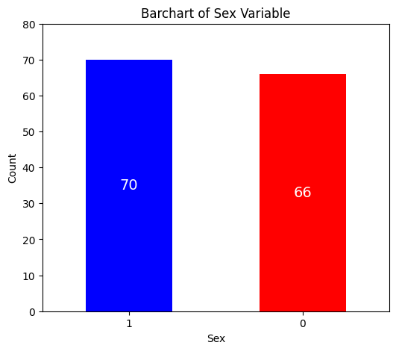
BGA_df.describe().map('{:,.3f}'.format)
Sex WT2 HT2 WT9 HT9 LG9 ST9 WT18
count 136.000 136.000 136.000 136.000 136.000 136.000 136.000 136.000
mean 0.515 13.209 87.796 31.626 135.493 27.675 64.566 64.871
std 0.502 1.607 3.360 5.969 5.496 2.461 15.448 10.674
min 0.000 10.100 80.900 19.900 121.400 21.800 22.000 42.900
25% 0.000 12.200 85.975 27.875 132.500 26.300 57.000 56.875
50% 1.000 13.200 87.700 30.900 135.700 27.300 64.000 65.100
75% 1.000 14.100 89.700 34.125 139.400 28.650 73.000 70.850
max 1.000 18.600 98.200 66.800 152.500 40.400 121.000 110.200
HT18 LG18 ST18 Soma
count 136.000 136.000 136.000 136.000
mean 172.579 35.840 167.132 3.960
std 8.844 2.567 49.719 1.435
min 153.600 30.000 77.000 1.000
25% 166.150 34.175 124.000 3.000
50% 172.500 35.750 150.500 4.000
75% 179.225 37.225 214.000 5.000
max 195.100 44.100 260.000 7.000
# Generate heatmap for correlation matrix analysis.
corr = BGA_df.corr()
fig, ax = plt.subplots()
sns.heatmap(corr, annot=True, fmt=".2f", xticklabels=corr.columns, yticklabels=corr.columns, vmin=-1, vmax=1, cmap="RdBu", ax=ax)
plt.show()
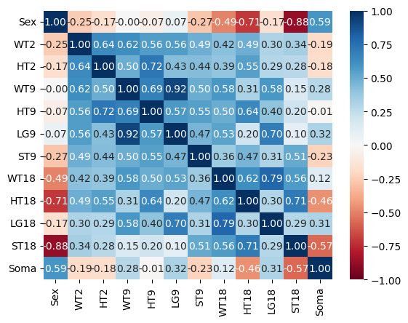

- The data from the Berkeley Guidance study included the coding for gender as: 0 = males, 1= females. Generate a scatter-plot matrix of all continuous variables. Group the variables by gender so that each paired observation has a gender-associated label. Explain the relationships that you see. (20 points)

# Create required dataframe for males.
BGA_0 = BGA_df[BGA_df['Sex'] == 0]
BGA_all0 = BGA_0[['WT2','HT2','WT9','HT9', 'LG9', 'ST9','WT18', 'HT18', 'LG18', 'ST18', 'Soma']]
# View summary statistics for males.
BGA_all0.describe().map('{:,.2f}'.format)
WT2 HT2 WT9 HT9 LG9 ST9 WT18 HT18 LG18
count 66.00 66.00 66.00 66.00 66.00 66.00 66.00 66.00 66.00
mean 13.63 88.37 31.63 135.89 27.50 68.92 70.27 178.98 36.29
std 1.63 3.32 6.16 5.38 2.48 14.67 9.98 6.52 2.49
min 10.10 81.30 19.90 122.00 21.80 30.00 42.90 160.90 30.00
25% 12.30 86.40 28.85 132.50 26.30 61.00 65.95 174.53 35.10
50% 13.60 88.35 31.00 135.60 27.25 68.00 69.35 178.90 36.50
75% 14.30 90.60 33.27 139.50 28.43 74.75 74.45 182.62 37.27
max 18.60 98.20 66.80 147.50 40.40 121.00 110.20 195.10 44.10
ST18 Soma
count 66.00 66.00
mean 212.09 3.09
std 28.59 1.45
min 145.00 1.00
25% 191.25 2.00
50% 214.50 3.00
75% 233.75 4.00
max 260.00 7.00

# Generate heatmap for correlation matrix analysis for males.
corr = BGA_all0.corr()
fig, ax = plt.subplots()
sns.heatmap(corr, annot=True, fmt=".2f", xticklabels=corr.columns, yticklabels=corr.columns, vmin=-1, vmax=1, cmap="RdBu", ax=ax)
plt.show()
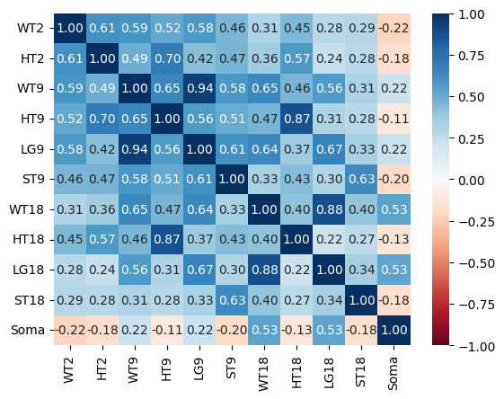

# Generate requested scatter plot matrix for males.
scatter_matrix(BGA_all0, diagonal="kde", figsize =(12, 12))
plt.show()
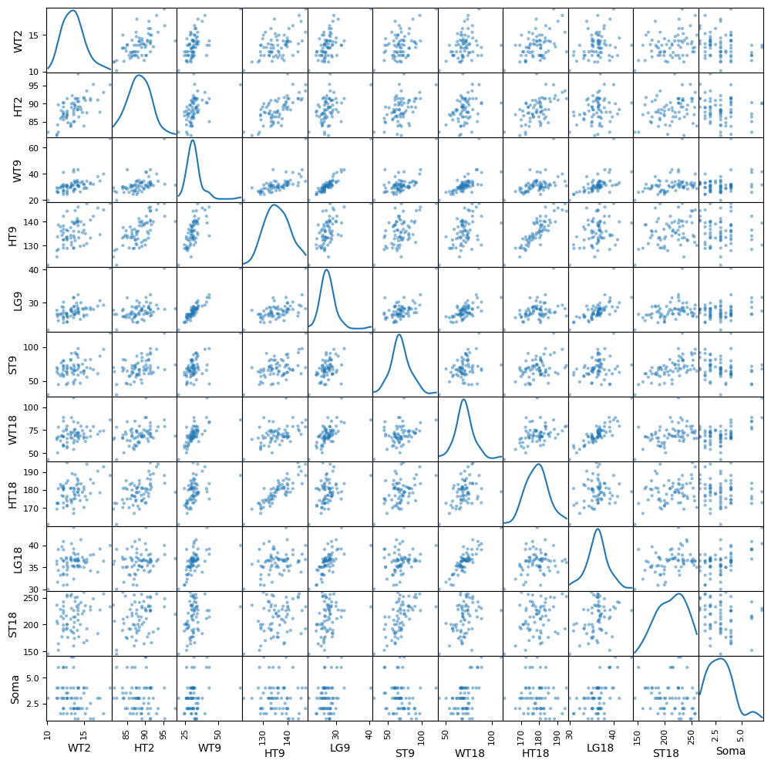

# Create required dataframe for females.
BGA_1 = BGA_df[BGA_df['Sex'] == 1]
BGA_all1 = BGA_1[['WT2','HT2','WT9','HT9', 'LG9', 'ST9','WT18', 'HT18', 'LG18', 'ST18','Soma']]
# View summary statistics for females.
BGA_all1.describe().map('{:,.2f}'.format)
WT2 HT2 WT9 HT9 LG9 ST9 WT18 HT18 LG18
count 70.00 70.00 70.00 70.00 70.00 70.00 70.00 70.00 70.00
mean 12.82 87.25 31.62 135.12 27.84 60.46 59.78 166.54 35.42
std 1.49 3.33 5.82 5.61 2.45 15.13 8.66 6.07 2.58
min 10.20 80.90 22.00 121.40 22.60 22.00 44.10 153.60 30.30
25% 11.80 85.67 27.62 132.88 26.30 51.25 54.78 163.00 33.52
50% 12.70 87.10 30.65 135.70 27.45 59.00 58.30 166.75 34.85
75% 13.47 88.90 34.48 138.78 29.25 68.75 64.80 170.25 37.08
max 17.00 97.30 47.40 152.50 32.70 107.00 97.70 183.20 42.90
ST18 Soma
count 70.00 70.00
mean 124.74 4.78
std 17.61 0.81
min 77.00 3.00
25% 114.50 4.00
50% 124.50 5.00
75% 135.00 5.00
max 182.00 7.00

# Generate heatmap for correlation matrix analysis for females.
corr = BGA_all1.corr()
fig, ax = plt.subplots()
sns.heatmap(corr, annot=True, fmt=".2f", xticklabels=corr.columns, yticklabels=corr.columns, vmin=-1, vmax=1, cmap="RdBu", ax=ax)
plt.show()
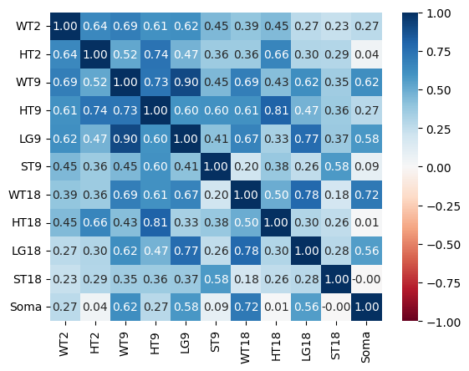

# Generate requested scatter plot matrix for females.
scatter_matrix(BGA_all1, diagonal="kde",figsize =(12, 12))
plt.show()
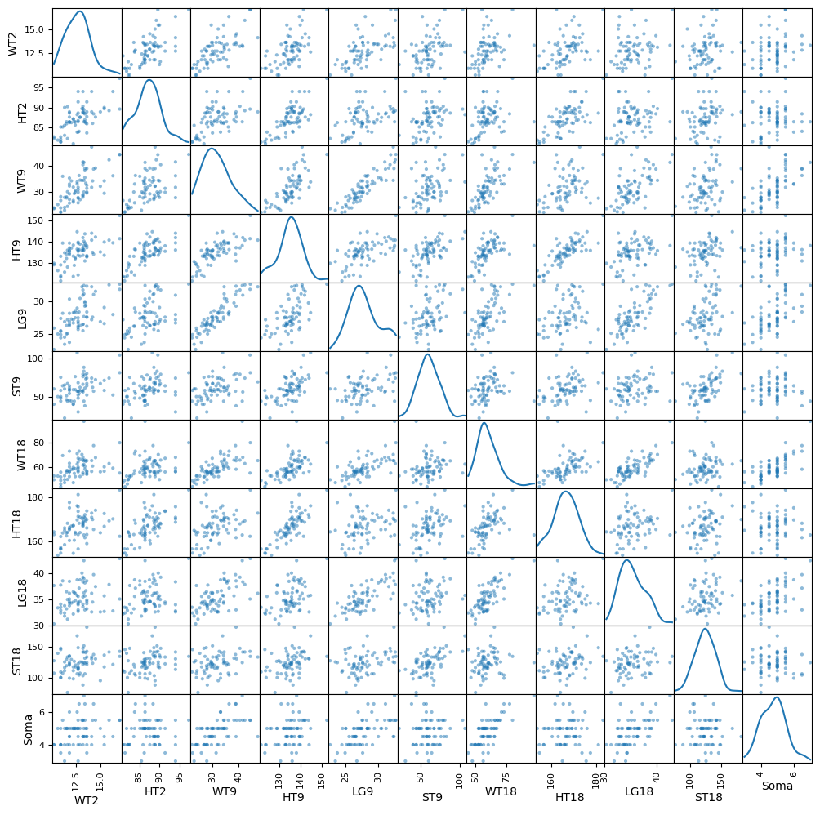

# Evaluating 'WT2' by 'Sex' (0 = male, 1 = female).
# Barchart for the 'WT2' by mean 'Sex'.
dfg = BGA_df.groupby(['Sex'])['WT2'].mean()
ax = dfg.plot(kind='bar', title='Age 2 Weight by Sex', ylabel='Age 2 Weight', xlabel='Sex', color= ['r','b'], rot=0, figsize=(6,5))
ax.bar_label(ax.containers[0], label_type='center', color='w', fontsize=14, fmt=lambda dfg: f'{dfg:.2f} kg')
plt.yticks(np.arange(0,16,step=1))
plt.show()
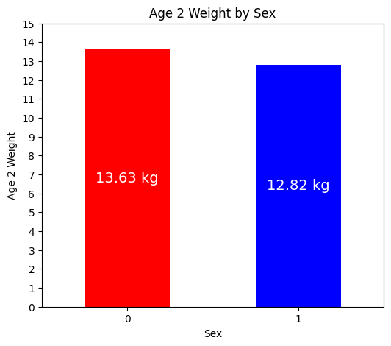

# Boxplots for the 'WT2' by 'Sex'.
grouped = BGA_df.groupby('Sex')['WT2']
fig = plt.figure(figsize =(6, 5))
ax = fig.add_subplot(111)
# Creating axes instance
bp = ax.boxplot(x=[Sex.values for name, Sex in grouped],
tick_labels=grouped.groups.keys(), patch_artist = True, notch ='True',
showmeans=True, meanline=True, meanprops=dict(color='red', linewidth=2, linestyle='--'))
for patch, color in zip(bp['boxes'], 'green'):
patch.set_facecolor('green')
# Changing color and linewidth of whiskers.
for whisker in bp['whiskers']:
whisker.set(color ='green',
linewidth = 1.5,
linestyle =":")
# Changing color and linewidth of caps.
for cap in bp['caps']:
cap.set(color ='black',
linewidth = 2)
# Changing color and linewidth of median.
for median in bp['medians']:
median.set(color ='blue',
linewidth = 3)
# Changing style of fliers.
for flier in bp['fliers']:
flier.set(marker ='D',
alpha = 0.5)
# Set title.
ax.set_title('Age 2 Weight by Sex', fontsize=12)
# Set axis labels.
ax.set_ylabel('Age 2 Weight')
ax.set_xlabel('Sex')
# Set axis limits.
plt.yticks(np.arange(9,21,step=1))
plt.show()
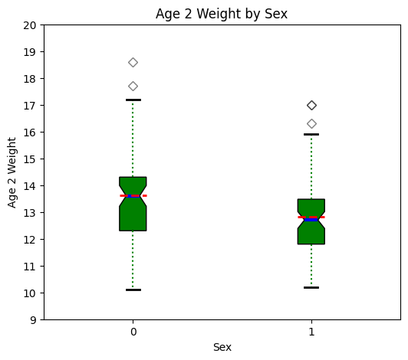

At Age 2, males can be slightly heavier than females, but there is probably not a significant difference.

# Evaluating 'HT2' by 'Sex'.
# Barchart for the 'HT2' by mean 'Sex'.
dfg = BGA_df.groupby(['Sex'])['HT2'].mean()
ax = dfg.plot(kind='bar', title='Age 2 Height by Sex', ylabel='Age 2 Height', xlabel='Sex', color= ['r','b'], rot=0, figsize=(6,5))
ax.bar_label(ax.containers[0], label_type='center', color='w', fontsize=14, fmt=lambda dfg: f'{dfg:.2f} cm')
plt.yticks(np.arange(0,101,step=10))
plt.show()
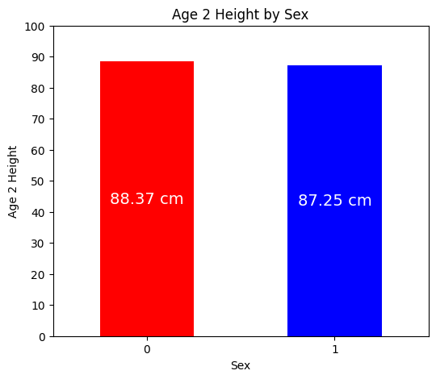

# Boxplots for the 'HT2' by 'Sex'.
grouped = BGA_df.groupby('Sex')['HT2']
fig = plt.figure(figsize =(6, 5))
ax = fig.add_subplot(111)
# Creating axes instance
bp = ax.boxplot(x=[Sex.values for name, Sex in grouped],
tick_labels=grouped.groups.keys(), patch_artist = True, notch ='True',
showmeans=True, meanline=True, meanprops=dict(color='red', linewidth=2, linestyle='--'))
for patch, color in zip(bp['boxes'], 'green'):
patch.set_facecolor('green')
# Changing color and linewidth of whiskers.
for whisker in bp['whiskers']:
whisker.set(color ='green',
linewidth = 1.5,
linestyle =":")
# Changing color and linewidth of caps.
for cap in bp['caps']:
cap.set(color ='black',
linewidth = 2)
# Changing color and linewidth of median.
for median in bp['medians']:
median.set(color ='blue',
linewidth = 3)
# Changing style of fliers.
for flier in bp['fliers']:
flier.set(marker ='D',
alpha = 0.5)
# Set title.
ax.set_title('Age 2 Height by Sex', fontsize=12)
# Set axis labels.
ax.set_ylabel('Age 2 Height')
ax.set_xlabel('Sex')
# Set axis limits.
plt.yticks(np.arange(78,103,step=2))
plt.show()
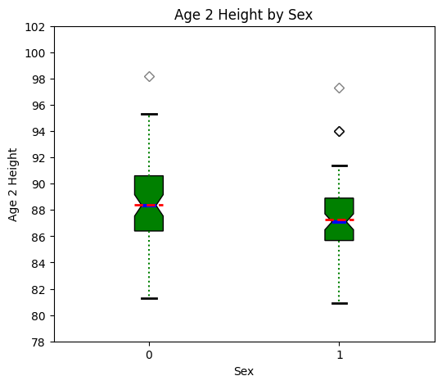

At Age 2, males can be slightly taller than females, but there is probably not a significant difference.

# Evaluating 'WT9' by 'Sex' (0 = male, 1 = female).
# Barchart for the 'WT9' by mean 'Sex'.
dfg = BGA_df.groupby(['Sex'])['WT9'].mean()
ax = dfg.plot(kind='bar', title='Age 9 Weight by Sex', ylabel='Age 9 Weight', xlabel='Sex', color= ['r','b'], rot=0, figsize=(6,5))
ax.bar_label(ax.containers[0], label_type='center', color='w', fontsize=14, fmt=lambda dfg: f'{dfg:.2f} kg')
plt.yticks(np.arange(0,41,step=5))
plt.show()
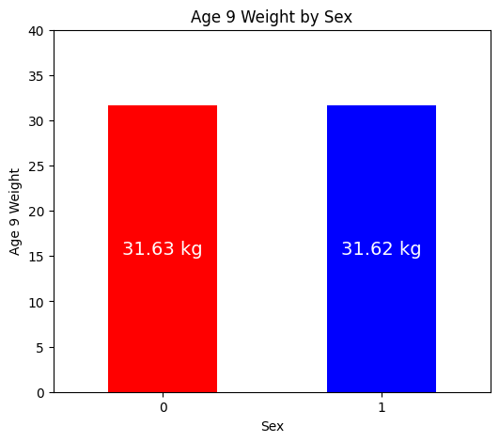

# Boxplots for the 'WT9' by 'Sex'.
grouped = BGA_df.groupby('Sex')['WT9']
fig = plt.figure(figsize =(6, 5))
ax = fig.add_subplot(111)
# Creating axes instance
bp = ax.boxplot(x=[Sex.values for name, Sex in grouped],
tick_labels=grouped.groups.keys(), patch_artist = True, notch ='True',
showmeans=True, meanline=True, meanprops=dict(color='red', linewidth=2, linestyle='--'))
for patch, color in zip(bp['boxes'], 'green'):
patch.set_facecolor('green')
# Changing color and linewidth of whiskers.
for whisker in bp['whiskers']:
whisker.set(color ='green',
linewidth = 1.5,
linestyle =":")
# Changing color and linewidth of caps.
for cap in bp['caps']:
cap.set(color ='black',
linewidth = 2)
# Changing color and linewidth of median.
for median in bp['medians']:
median.set(color ='blue',
linewidth = 3)
# Changing style of fliers.
for flier in bp['fliers']:
flier.set(marker ='D',
alpha = 0.5)
# Set title.
ax.set_title('Age 9 Weight by Sex', fontsize=12)
# Set axis labels.
ax.set_ylabel('Age 9 Weight')
ax.set_xlabel('Sex')
# Set axis limits.
plt.yticks(np.arange(10,76,step=5))
plt.show()
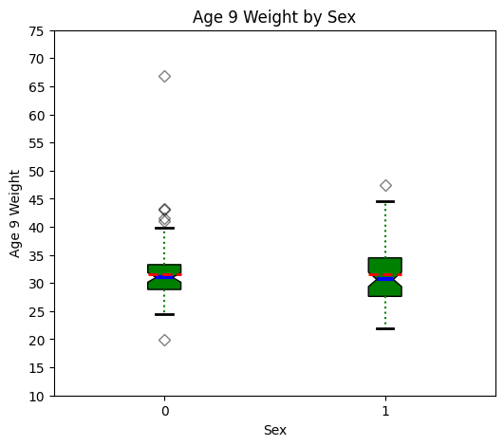

At Age 9, females can be slightly heavier than males, but there is probably not a significant difference.

# Evaluating 'HT9' by 'Sex' (0 = male, 1 = female).
# Barchart for the 'HT9' by mean 'Sex'.
dfg = BGA_df.groupby(['Sex'])['HT9'].mean()
ax = dfg.plot(kind='bar', title='Age 9 Height by Sex', ylabel='Age 9 Height', xlabel='Sex', color= ['r','b'], rot=0, figsize=(6,5))
ax.bar_label(ax.containers[0], label_type='center', color='w', fontsize=14, fmt=lambda dfg: f'{dfg:.2f} cm')
plt.yticks(np.arange(0,151,step=10))
plt.show()
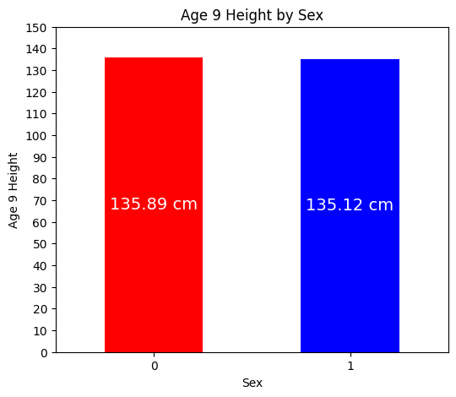

# Boxplots for the 'HT9' by 'Sex'.
grouped = BGA_df.groupby('Sex')['HT9']
fig = plt.figure(figsize =(6, 5))
ax = fig.add_subplot(111)
# Creating axes instance
bp = ax.boxplot(x=[Sex.values for name, Sex in grouped],
tick_labels=grouped.groups.keys(), patch_artist = True, notch ='True',
showmeans=True, meanline=True, meanprops=dict(color='red', linewidth=2, linestyle='--'))
for patch, color in zip(bp['boxes'], 'green'):
patch.set_facecolor('green')
# Changing color and linewidth of whiskers.
for whisker in bp['whiskers']:
whisker.set(color ='green',
linewidth = 1.5,
linestyle =":")
# Changing color and linewidth of caps.
for cap in bp['caps']:
cap.set(color ='black',
linewidth = 2)
# Changing color and linewidth of median.
for median in bp['medians']:
median.set(color ='blue',
linewidth = 3)
# Changing style of fliers.
for flier in bp['fliers']:
flier.set(marker ='D',
alpha = 0.5)
# Set title.
ax.set_title('Age 9 Height by Sex', fontsize=12)
# Set axis labels.
ax.set_ylabel('Age 9 Height')
ax.set_xlabel('Sex')
# Set axis limits.
plt.yticks(np.arange(115,161,step=5))
plt.show()
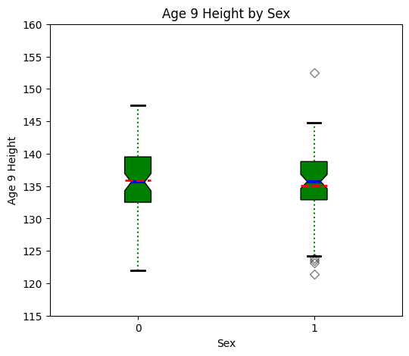

At Age 9, there is probably not a significant difference in height between males and females.

# Evaluating 'LG9' by 'Sex' (0 = male, 1 = female).
# Barchart for the 'LG9' by mean 'Sex'.
dfg = BGA_df.groupby(['Sex'])['LG9'].mean()
ax = dfg.plot(kind='bar', title='Age 9 Leg Circumference by Sex', ylabel='Age 9 Leg Circumference', xlabel='Sex', color= ['r','b'], rot=0, figsize=(6,5))
ax.bar_label(ax.containers[0], label_type='center', color='w', fontsize=14, fmt=lambda dfg: f'{dfg:.2f} cm')
plt.yticks(np.arange(0,36,step=5))
plt.show()
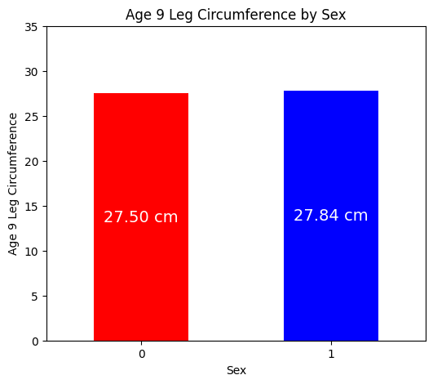

# Boxplots for the 'LG9' by 'Sex'.
grouped = BGA_df.groupby('Sex')['LG9']
fig = plt.figure(figsize =(6, 5))
ax = fig.add_subplot(111)
# Creating axes instance
bp = ax.boxplot(x=[Sex.values for name, Sex in grouped],
tick_labels=grouped.groups.keys(), patch_artist = True, notch ='True',
showmeans=True, meanline=True, meanprops=dict(color='red', linewidth=2, linestyle='--'))
for patch, color in zip(bp['boxes'], 'green'):
patch.set_facecolor('green')
# Changing color and linewidth of whiskers.
for whisker in bp['whiskers']:
whisker.set(color ='green',
linewidth = 1.5,
linestyle =":")
# Changing color and linewidth of caps.
for cap in bp['caps']:
cap.set(color ='black',
linewidth = 2)
# Changing color and linewidth of median.
for median in bp['medians']:
median.set(color ='blue',
linewidth = 3)
# Changing style of fliers.
for flier in bp['fliers']:
flier.set(marker ='D',
alpha = 0.5)
# Set title.
ax.set_title('Age 9 Leg Circumference by Sex', fontsize=12)
# Set axis labels.
ax.set_ylabel('Age 9 Leg Circumference')
ax.set_xlabel('Sex')
# Set axis limits.
plt.yticks(np.arange(20,43,step=2))
plt.show()
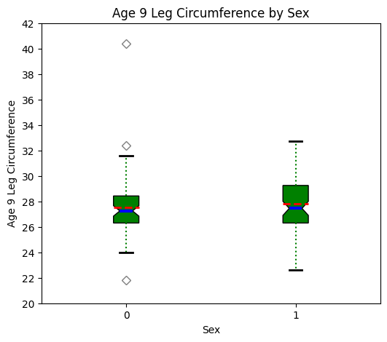

At Age 9, there is probably not a significant difference in leg circumference between males and females.

# Evaluating 'ST9' by 'Sex' (0 = male, 1 = female).
# Barchart for the 'ST9' by mean 'Sex'.
dfg = BGA_df.groupby(['Sex'])['ST9'].mean()
ax = dfg.plot(kind='bar', title='Age 9 Strength by Sex', ylabel='Age 9 Strength', xlabel='Sex', color= ['r','b'], rot=0, figsize=(6,5))
ax.bar_label(ax.containers[0], label_type='center', color='w', fontsize=14, fmt=lambda dfg: f'{dfg:.2f} kg')
plt.yticks(np.arange(0,81,step=10))
plt.show()
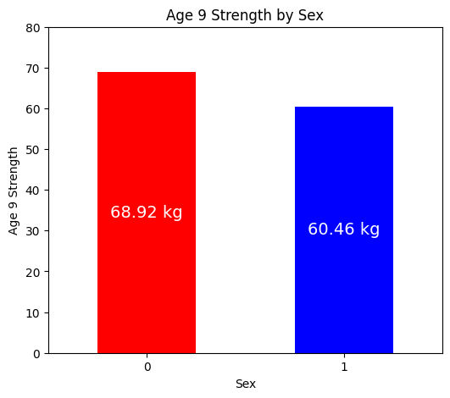

# Boxplots for the 'ST9' by 'Sex'.
grouped = BGA_df.groupby('Sex')['ST9']
fig = plt.figure(figsize =(6, 5))
ax = fig.add_subplot(111)
# Creating axes instance
bp = ax.boxplot(x=[Sex.values for name, Sex in grouped],
tick_labels=grouped.groups.keys(), patch_artist = True, notch ='True',
showmeans=True, meanline=True, meanprops=dict(color='red', linewidth=2, linestyle='--'))
for patch, color in zip(bp['boxes'], 'green'):
patch.set_facecolor('green')
# Changing color and linewidth of whiskers.
for whisker in bp['whiskers']:
whisker.set(color ='green',
linewidth = 1.5,
linestyle =":")
# Changing color and linewidth of caps.
for cap in bp['caps']:
cap.set(color ='black',
linewidth = 2)
# Changing color and linewidth of median.
for median in bp['medians']:
median.set(color ='blue',
linewidth = 3)
# Changing style of fliers.
for flier in bp['fliers']:
flier.set(marker ='D',
alpha = 0.5)
# Set title.
ax.set_title('Age 9 Strength by Sex', fontsize=12)
# Set axis labels.
ax.set_ylabel('Age 9 Strength')
ax.set_xlabel('Sex')
# Set axis limits.
plt.yticks(np.arange(10,131,step=10))
plt.show()
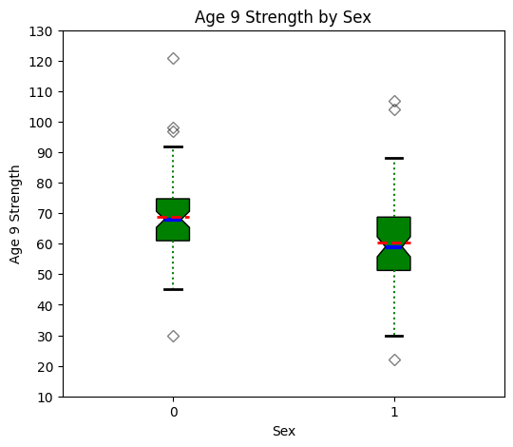

At Age 9, males can be slightly stronger than females, but there is probably not a significant difference.

# Evaluating 'WT18' by 'Sex' (0 = male, 1 = female).
# Barchart for the 'WT18' by mean 'Sex'.
dfg = BGA_df.groupby(['Sex'])['WT18'].mean()
ax = dfg.plot(kind='bar', title='Age 18 Weight by Sex', ylabel='Age 18 Weight', xlabel='Sex', color= ['r','b'], rot=0, figsize=(6,5))
ax.bar_label(ax.containers[0], label_type='center', color='w', fontsize=14, fmt=lambda dfg: f'{dfg:.2f} kg')
plt.yticks(np.arange(0,81,step=5))
plt.show()
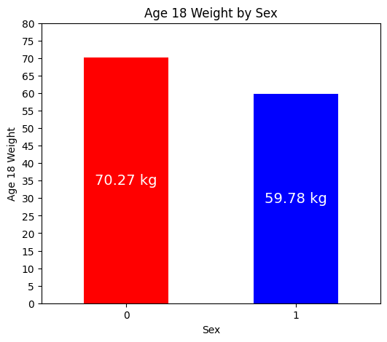

# Boxplots for the 'WT18' by 'Sex'.
grouped = BGA_df.groupby('Sex')['WT18']
fig = plt.figure(figsize =(6, 5))
ax = fig.add_subplot(111)
# Creating axes instance
bp = ax.boxplot(x=[Sex.values for name, Sex in grouped],
tick_labels=grouped.groups.keys(), patch_artist = True, notch ='True',
showmeans=True, meanline=True, meanprops=dict(color='red', linewidth=2, linestyle='--'))
for patch, color in zip(bp['boxes'], 'green'):
patch.set_facecolor('green')
# Changing color and linewidth of whiskers.
for whisker in bp['whiskers']:
whisker.set(color ='green',
linewidth = 1.5,
linestyle =":")
# Changing color and linewidth of caps.
for cap in bp['caps']:
cap.set(color ='black',
linewidth = 2)
# Changing color and linewidth of median.
for median in bp['medians']:
median.set(color ='blue',
linewidth = 3)
# Changing style of fliers.
for flier in bp['fliers']:
flier.set(marker ='D',
alpha = 0.5)
# Set title.
ax.set_title('Age 18 Weight by Sex', fontsize=12)
# Set axis labels.
ax.set_ylabel('Age 18 Weight')
ax.set_xlabel('Sex')
# Set axis limits.
plt.yticks(np.arange(30,131,step=10))
plt.show()
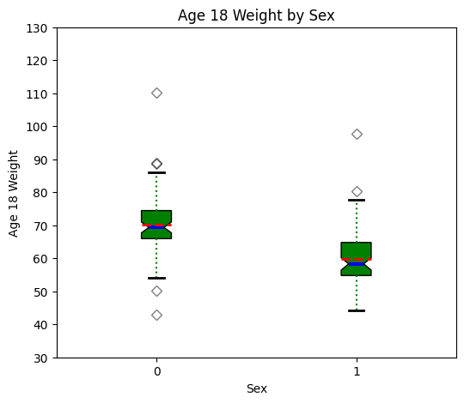

At Age 18, there is probably a significant difference in weight with males being generally heavier than females.

# Evaluating 'HT18' by 'Sex' (0 = male, 1 = female).
# Barchart for the 'HT18' by mean 'Sex'.
dfg = BGA_df.groupby(['Sex'])['HT18'].mean()
ax = dfg.plot(kind='bar', title='Age 18 Height by Sex', ylabel='Age 18 Height', xlabel='Sex', color= ['r','b'], rot=0, figsize=(6,5))
ax.bar_label(ax.containers[0], label_type='center', color='w', fontsize=14, fmt=lambda dfg: f'{dfg:.2f} cm')
plt.yticks(np.arange(0,191,step=10))
plt.show()
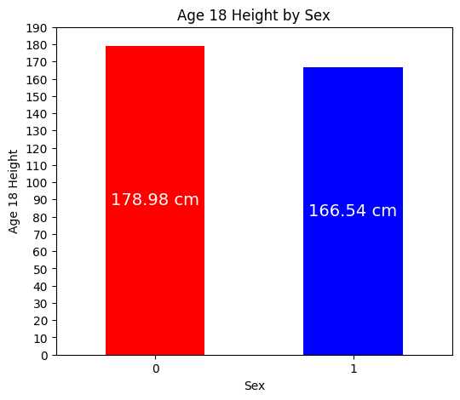

# Boxplots for the 'HT18' by 'Sex'.
grouped = BGA_df.groupby('Sex')['HT18']
fig = plt.figure(figsize =(6, 5))
ax = fig.add_subplot(111)
# Creating axes instance
bp = ax.boxplot(x=[Sex.values for name, Sex in grouped],
tick_labels=grouped.groups.keys(), patch_artist = True, notch ='True',
showmeans=True, meanline=True, meanprops=dict(color='red', linewidth=2, linestyle='--'))
for patch, color in zip(bp['boxes'], 'green'):
patch.set_facecolor('green')
# Changing color and linewidth of whiskers.
for whisker in bp['whiskers']:
whisker.set(color ='green',
linewidth = 1.5,
linestyle =":")
# Changing color and linewidth of caps.
for cap in bp['caps']:
cap.set(color ='black',
linewidth = 2)
# Changing color and linewidth of median.
for median in bp['medians']:
median.set(color ='blue',
linewidth = 3)
# Changing style of fliers.
for flier in bp['fliers']:
flier.set(marker ='D',
alpha = 0.5)
# Set title.
ax.set_title('Age 18 Height by Sex', fontsize=12)
# Set axis labels.
ax.set_ylabel('Age 18 Height')
ax.set_xlabel('Sex')
# Set axis limits.
plt.yticks(np.arange(145,206,step=5))
plt.show()
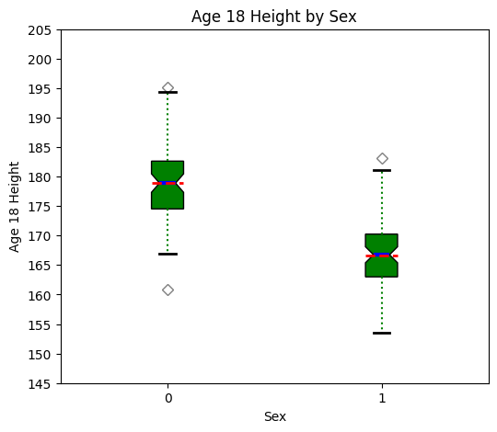

At Age 18, there is a significant difference in height with males being generally taller than females.

# Evaluating 'LG18' by 'Sex' (0 = male, 1 = female).
# Barchart for the 'LG18' by mean 'Sex'.
dfg = BGA_df.groupby(['Sex'])['LG18'].mean()
ax = dfg.plot(kind='bar', title='Age 18 Leg Circumference by Sex', ylabel='Age 18 Leg Circumference', xlabel='Sex', color= ['r','b'], rot=0, figsize=(6,5))
ax.bar_label(ax.containers[0], label_type='center', color='w', fontsize=14, fmt=lambda dfg: f'{dfg:.2f} cm')
plt.yticks(np.arange(0,46,step=5))
plt.show()
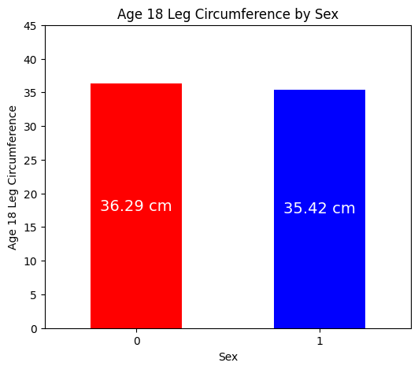

# Boxplots for the 'LG18' by 'Sex'.
grouped = BGA_df.groupby('Sex')['LG18']
fig = plt.figure(figsize =(6, 5))
ax = fig.add_subplot(111)
# Creating axes instance
bp = ax.boxplot(x=[Sex.values for name, Sex in grouped],
tick_labels=grouped.groups.keys(), patch_artist = True, notch ='True',
showmeans=True, meanline=True, meanprops=dict(color='red', linewidth=2, linestyle='--'))
for patch, color in zip(bp['boxes'], 'green'):
patch.set_facecolor('green')
# Changing color and linewidth of whiskers.
for whisker in bp['whiskers']:
whisker.set(color ='green',
linewidth = 1.5,
linestyle =":")
# Changing color and linewidth of caps.
for cap in bp['caps']:
cap.set(color ='black',
linewidth = 2)
# Changing color and linewidth of median.
for median in bp['medians']:
median.set(color ='blue',
linewidth = 3)
# Changing style of fliers.
for flier in bp['fliers']:
flier.set(marker ='D',
alpha = 0.5)
# Set title.
ax.set_title('Age 18 Leg Circumference by Sex', fontsize=12)
# Set axis labels.
ax.set_ylabel('Age 18 Leg Circumference')
ax.set_xlabel('Sex')
# Set axis limits.
plt.yticks(np.arange(28,48,step=2))
plt.show()
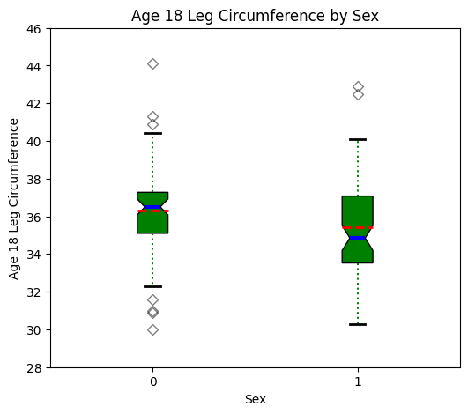

At Age 18, males can have a slightly larger leg circumference than females, but there is probably not a significant difference.

# Evaluating 'ST18' by 'Sex' (0 = male, 1 = female).
# Barchart for the 'ST18' by mean 'Sex'.
dfg = BGA_df.groupby(['Sex'])['ST18'].mean()
ax = dfg.plot(kind='bar', title='Age 18 Strength by Sex', ylabel='Age 18 Strength', xlabel='Sex', color= ['r','b'], rot=0, figsize=(6,5))
ax.bar_label(ax.containers[0], label_type='center', color='w', fontsize=14, fmt=lambda dfg: f'{dfg:.2f} kg')
plt.yticks(np.arange(0,221,step=10))
plt.show()
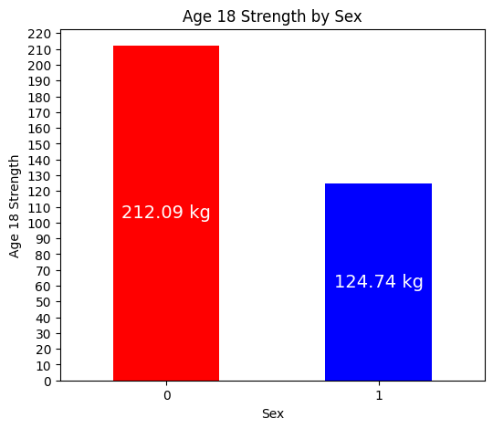

# Boxplots for the 'ST18' by 'Sex'.
grouped = BGA_df.groupby('Sex')['ST18']
fig = plt.figure(figsize =(6, 5))
ax = fig.add_subplot(111)
# Creating axes instance
bp = ax.boxplot(x=[Sex.values for name, Sex in grouped],
tick_labels=grouped.groups.keys(), patch_artist = True, notch ='True',
showmeans=True, meanline=True, meanprops=dict(color='red', linewidth=2, linestyle='--'))
for patch, color in zip(bp['boxes'], 'green'):
patch.set_facecolor('green')
# Changing color and linewidth of whiskers.
for whisker in bp['whiskers']:
whisker.set(color ='green',
linewidth = 1.5,
linestyle =":")
# Changing color and linewidth of caps.
for cap in bp['caps']:
cap.set(color ='black',
linewidth = 2)
# Changing color and linewidth of median.
for median in bp['medians']:
median.set(color ='blue',
linewidth = 3)
# Changing style of fliers.
for flier in bp['fliers']:
flier.set(marker ='D',
alpha = 0.5)
# Set title.
ax.set_title('Age 18 Strength by Sex', fontsize=12)
# Set axis labels.
ax.set_ylabel('Age 18 Strength')
ax.set_xlabel('Sex')
# Set axis limits.
plt.yticks(np.arange(60,281,step=20))
plt.show()
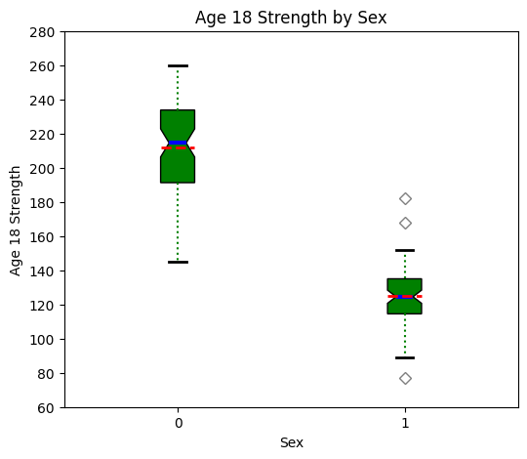

At Age 18, there is clearly a significant difference in strength with males being generally stronger than females.

# Evaluating 'Soma' by 'Sex' (0 = male, 1 = female).
# Barchart for the 'Soma' by mean 'Sex'.
dfg = BGA_df.groupby(['Sex'])['Soma'].mean()
ax = dfg.plot(kind='bar', title='Somatotype by Sex', ylabel='Somatotype', xlabel='Sex', color= ['r','b'], rot=0, figsize=(6,5))
ax.bar_label(ax.containers[0], label_type='center', color='w', fontsize=14, fmt=lambda dfg: f'{dfg:.2f}')
plt.yticks(np.arange(0,6,step=0.5))
plt.show()
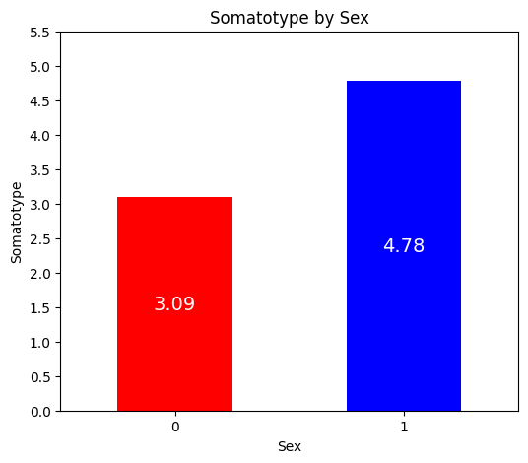

# Boxplots for the 'Soma' by 'Sex'.
grouped = BGA_df.groupby('Sex')['Soma']
fig = plt.figure(figsize =(6, 5))
ax = fig.add_subplot(111)
# Creating axes instance
bp = ax.boxplot(x=[Sex.values for name, Sex in grouped],
tick_labels=grouped.groups.keys(), patch_artist = True, notch ='True',
showmeans=True, meanline=True, meanprops=dict(color='red', linewidth=2, linestyle='--'))
for patch, color in zip(bp['boxes'], 'green'):
patch.set_facecolor('green')
# Changing color and linewidth of whiskers.
for whisker in bp['whiskers']:
whisker.set(color ='green',
linewidth = 1.5,
linestyle =":")
# Changing color and linewidth of caps.
for cap in bp['caps']:
cap.set(color ='black',
linewidth = 2)
# Changing color and linewidth of median.
for median in bp['medians']:
median.set(color ='blue',
linewidth = 3)
# Changing style of fliers.
for flier in bp['fliers']:
flier.set(marker ='D',
alpha = 0.5)
# Set title.
ax.set_title('Somatotype by Sex', fontsize=12)
# Set axis labels.
ax.set_ylabel('Somatotype')
ax.set_xlabel('Sex')
# Set axis limits.
plt.yticks(np.arange(1,7.5,step=0.5))
plt.show()
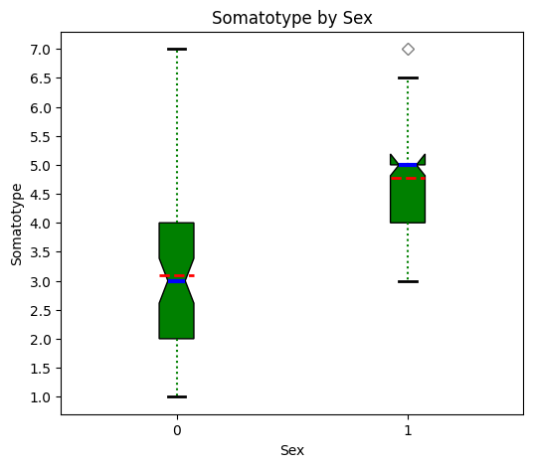

Genernally speaking, males have a greater variation in the physiological index than females. The index usually has three values for endomorphic, mesomorphic, and ectomorphic traits. Given that averaging them would not make sense, I will make the assumption that the largest value of the three is being represented here. With that in mind, there is a significant difference in Somatype with females conforming to one of the traits more than males do.

- Generate two linear regressions that predict WT18 (weight at 18 years old). (50 points)

One regression model is to predict the weight of boys, and the other is to predict the weight of girls. Interpret the results.
Generate a multiple linear regression model to explain WT18 using the variables HT2, WT2, HT9, WT9, and ST9. Find the R-squared, the overall ANOVA table, and the overall F-test. Compute the t-statistics to test each of the coefficients against to be 0. State the conclusions from this test.
# Create required dataframe for males.
BGA_0 = BGA_df[BGA_df['Sex'] == 0]
BGA_pred0 = BGA_0[['WT2','HT2','WT9','HT9','ST9','WT18']]
# View summary statistics.
BGA_pred0.describe().map('{:,.2f}'.format)
WT2 HT2 WT9 HT9 ST9 WT18
count 66.00 66.00 66.00 66.00 66.00 66.00
mean 13.63 88.37 31.63 135.89 68.92 70.27
std 1.63 3.32 6.16 5.38 14.67 9.98
min 10.10 81.30 19.90 122.00 30.00 42.90
25% 12.30 86.40 28.85 132.50 61.00 65.95
50% 13.60 88.35 31.00 135.60 68.00 69.35
75% 14.30 90.60 33.27 139.50 74.75 74.45
max 18.60 98.20 66.80 147.50 121.00 110.20

# Generate heatmap for correlation matrix analysis.
corr = BGA_pred0.corr()
fig, ax = plt.subplots()
sns.heatmap(corr, annot=True, fmt=".2f", xticklabels=corr.columns, yticklabels=corr.columns, vmin=-1, vmax=1, cmap="RdBu", ax=ax)
plt.show()
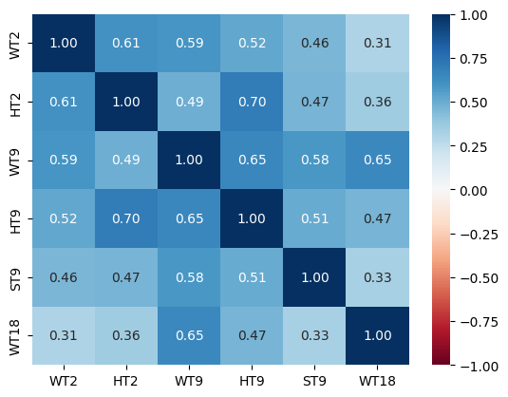

# Generate requested scatter plot matrix of required continuous variables.
scatter_matrix(BGA_pred0, diagonal="kde",figsize =(10, 10))
plt.show()
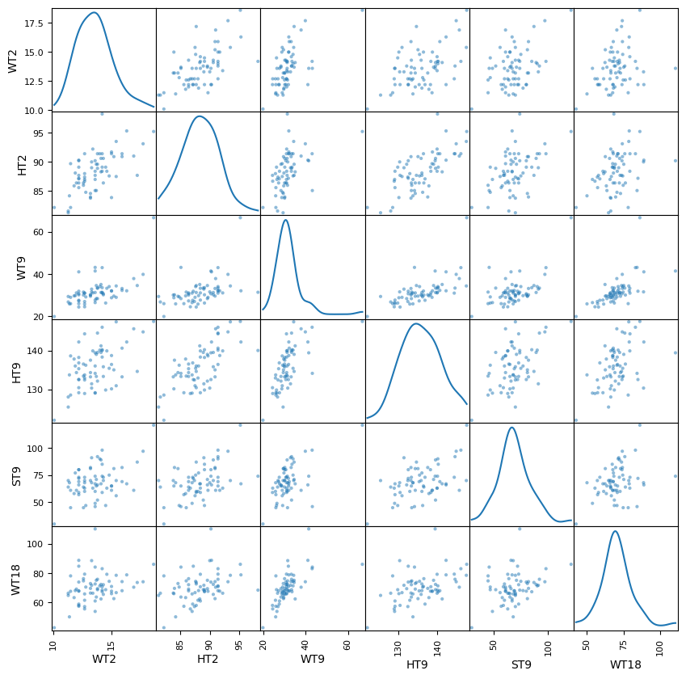

# Generate required multiple linear regression model for males.
lm = smf.ols(formula='WT18 ~ WT2 + HT2 + WT9 + HT9 + ST9', data=BGA_pred0).fit()
print(lm.params)
Intercept 5.571666
WT2 -1.064879
HT2 0.357979
WT9 1.134578
HT9 0.114871
ST9 -0.057023
dtype: float64
# Calculate the Total Sum of Squares (SST) for an empty model for WT18.
Y = BGA_pred0['WT18'].tolist()
Y_mean = np.mean(Y)
sst = np.sum((Y - Y_mean) ** 2)
print(f"SST = {sst:0,.3f}")
SST = 6,471.490
# Generate OLS Regression results for the multiple linear regression model.
print(lm.summary())
print('\n', '='*20, '\n')
# Residual Sum of Squares
print(f"RSS = {lm.ssr:0,.3f}")
# Sum of Squares Error
print(f"SSE = {sst-lm.ssr:0,.3f}")
OLS Regression Results
=============================================================================
Dep. Variable: WT18 R-squared: 0.444
Model: OLS Adj. R-squared: 0.398
Method: Least Squares F-statistic: 9.596
Date: Sun, 16 Feb 2025 Prob (F-statistic): 9.13-e07
Time: 14:30:57 Log-Likelihood: 225.58
No. Observations: 66 AIC: 463.2
Df Residuals: 60 BIC: 476.3
Df Model: 5
Covariance Type: nonrobust
=============================================================================
coef std err t P>|t| [0.025 0.975]
-----------------------------------------------------------------------------
Intercept 5.5717 31.925 0.175 0.862 -58.287 69.430
WT2 -1.0649 0.823 -1.294 0.200 -2.710 0.581
HT2 0.3580 0.451 0.794 0.430 -0.544 1.259
WT9 1.1346 0.238 4.769 0.000 0.659 1.610
HT9 0.1149 0.290 0.396 0.693 -0.465 0.695
ST9 -0.0570 0.084 -0.681 0.498 -0.224 0.110
=============================================================================
Omnibus: 12.581 Durbin-Watson: 1.513
Prob(Omnibus): 0.002 Jarque-Bera (JB): 23.189
Skew: 0.577 Prob(JB): 9.22-e06
Kurtosis: 5.665 Cond. No. 6.02e+03
=============================================================================
RSS = 3,596.021
SSE = 2,875.469
# Generate the absolute critical t-statistic.
t_critical = abs(scipy.stats.t.ppf(q=.05/2,df=5))
print(f'{t_critical:.3f}')
2.571
Interpret the results for males:
The required OLS regression model was run with Age 18 Weight (WT18) as the outcome variable for males. The R-squared value of 0.444 indicates that 44.4% of the variation in the predicted WT18 values can be explained by this multiple linear regression model. The Y intercept, beta0, equals 5.5717 kg. WT2, beta1, equals -1.0649 kg per 1 kg of weight, HT2, beta2, equals 0.358 kg per 1 cm of height, WT9, beta3, equals 1.1346 kg per 1 kg of weight, HT9, beta4, equals 0.1149 kg per 1 cm of height, and ST9, beta5, equals -0.057 kg per 1 kg of strength. The F-statistic of 9.596 brings attention to potential overfitting in this MLR model. Only the Age 9 Weight (WT9) variable had a p-value safely under the 0.05 alpha standard (rejecting H0 the null hypothesis), indicating clearly that the relationship between WT18 and WT9 is statistically significant. All of the other explanatory variables had p-values which notably exceeded the 0.05 alpha standard (accepting H0 the alternate hypothesis), indicating that the relationship between WT18 and those variables are not statistically significant.
With WT18 having a SST of 6,471.49, the MLR model using WT2, HT2, WT9, HT9, and ST9 variables reduced it 2,875.469 to a SSR of 3,596.021, primarily attributed to the WT9 variable. Normality was assessed on these variables with male and female data combined, and there were no glaring red flags in the Anderson-Darling and/or QQ plot assessments. Believe that the results were pretty much as one would expect with Age 9 Weight (WT9) being the only variable in the MLR model to effectively explain Age 18 Weight (WT18). Suggest that the other four explanatory variables should be removed from the MLR model, and some consideration be given to Age 18 Leg Circumference (LG18) and Age 18 Height (HT18), and possibly Age 18 Strength (ST18), given they share a reasonably strong correlation with the outcome variable as did Age 9 Weight (WT9).
Requested t-statistic assessment for coefficients:
The Intercept absolute t-value of 0.175 is less than the absolute t-critical value of 2.571, thus H0 the null hypothesis would be accepted, so the Intercept coefficient could possibly be zero.
The WT2 absolute t-value of 1.294 is less than the absolute t-critical value of 2.571, thus H0 the null hypothesis would be accepted, so the WT2 coefficient could possibly be zero. This is further confirmation that the relationship between the WT18 outcome variable and WT2 is not statistically significant.
The HT2 absolute t-value of 0.794 is less than the absolute t-critical value of 2.571, thus H0 the null hypothesis would be accepted, so the HT2 coefficient could possibly be zero. This is further confirmation that the relationship between the WT18 outcome variable and HT2 is not statistically significant.
The WT9 absolute t-value of 4.769 is greater than the absolute t-critical value of 2.571, thus H0 the null hypothesis would be rejected, and the H1 alternate hypothesis would be accepted, so the WT9 coefficient could not be zero. This is further confirmation that the relationship between the WT18 outcome variable and WT9 is statistically significant.
The HT9 absolute t-value of 0.396 is less than the absolute t-critical value of 2.571, thus H0 the null hypothesis would be accepted, so the HT9 coefficient could possibly be zero. This is further confirmation that the relationship between the WT18 outcome variable and HT9 is not statistically significant.
The ST9 absolute t-value of 0.681 is less than the absolute t-critical value of 2.571, thus H0 the null hypothesis would be rejected, and the H1 alternate hypothesis would be accepted, so the ST9 coefficient could not be zero. This is further confirmation that the relationship between the WT18 outcome variable and ST9 is not statistically significant.

# Create required dataframe for females.
BGA_1 = BGA_df[BGA_df['Sex'] == 1]
BGA_pred1 = BGA_1[['WT2','HT2','WT9','HT9','ST9','WT18']]
# View summary statistics.
BGA_pred1.describe().map('{:,.2f}'.format)
WT2 HT2 WT9 HT9 ST9 WT18
count 70.00 70.00 70.00 70.00 70.00 70.00
mean 12.82 87.25 31.62 135.12 60.46 59.78
std 1.49 3.33 5.82 5.61 15.13 8.66
min 10.20 80.90 22.00 121.40 22.00 44.10
25% 11.80 85.67 27.62 132.88 51.25 54.78
50% 12.70 87.10 30.65 135.70 59.00 58.30
75% 13.47 88.90 34.48 138.78 68.75 64.80
max 17.00 97.30 47.40 152.50 107.00 97.70

# Generate heatmap for correlation matrix analysis.
corr = BGA_pred1.corr()
fig, ax = plt.subplots()
sns.heatmap(corr, annot=True, fmt=".2f", xticklabels=corr.columns, yticklabels=corr.columns, vmin=-1, vmax=1, cmap="RdBu", ax=ax)
plt.show()
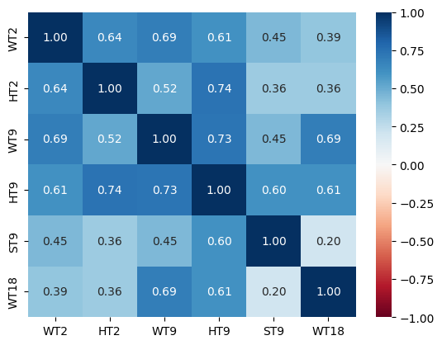

# Generate requested scatter plot matrix of required continuous variables.
scatter_matrix(BGA_pred1, diagonal="kde",figsize =(10, 10))
plt.show()
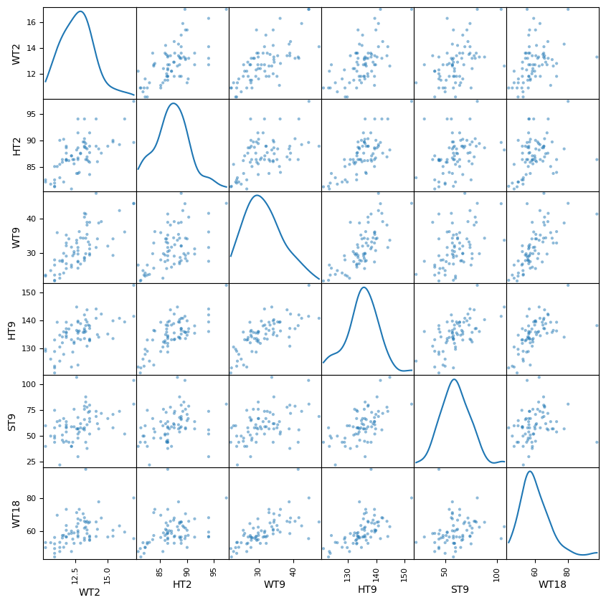

# Generate required multiple linear regression model for females.
lm = smf.ols(formula='WT18 ~ WT2 + HT2 + WT9 + HT9 + ST9', data=BGA_pred1).fit()
print(lm.params)
Intercept -24.004176
WT2 -0.609520
HT2 -0.462320
WT9 0.873788
HT9 0.844238
ST9 -0.161523
dtype: float64
# Calculate the Total Sum of Squares (SST) for an empty model for WT18.
Y = BGA_pred1['WT18'].tolist()
Y_mean = np.mean(Y)
sst = np.sum((Y - Y_mean) ** 2)
print(f"SST = {sst:0,.3f}")
SST = 5,179.233
# Generate OLS Regression results for the multiple linear regression model.
print(lm.summary())
print('\n', '='*20, '\n')
# Residual Sum of Squares
print(f"RSS = {lm.ssr:0,.3f}")
# Sum of Squares Error
print(f"SSE = {sst-lm.ssr:0,.3f}")
OLS Regression Results
=============================================================================
Dep. Variable: WT18 R-squared: 0.577
Model: OLS Adj. R-squared: 0.544
Method: Least Squares F-statistic: 17.46
Date: Sun, 16 Feb 2025 Prob (F-statistic): 7.24e-11
Time: 14:35:49 Log-Likelihood: 219.85
No. Observations: 70 AIC: 451.7
Df Residuals: 64 BIC: 465.2
Df Model: 5
Covariance Type: nonrobust
=============================================================================
coef std err t P>|t| [0.025 0.975]
-----------------------------------------------------------------------------
Intercept -24.0042 24.011 -1.000 0.321 -71.972 23.964
WT2 -0.6095 0.762 -0.800 0.427 -2.132 0.913
HT2 -0.4623 0.358 -1.292 0.201 -1.177 0.252
WT9 0.8738 0.206 4.249 0.000 0.463 1.285
HT9 0.8442 0.263 3.205 0.002 0.318 1.371
ST9 -0.1615 0.061 -2.659 0.010 -0.283 0.040
=============================================================================
Omnibus: 26.820 Durbin-Watson: 2.168
Prob(Omnibus): 0.000 Jarque-Bera (JB): 56.420
Skew: 1.272 Prob(JB): 5.61e-13
Kurtosis: 6.587 Cond. No. 6.03e+03
=============================================================================
RSS = 2,191.062
SSE = 2,988.171
# Generate the absolute critical t-statistic.
t_critical = abs(scipy.stats.t.ppf(q=.05/2,df=5))
print(f'{t_critical:.3f}')
2.571
Interpret the results for females:
The required OLS regression model was run with Age 18 Weight (WT18) as the outcome variable for females. The R-squared value of 0.577 indicates that 57.7% of the variation in the predicted WT18 values can be explained by this multiple linear regression model. The Y intercept, beta0, equals -24.0042 kg. WT2, beta1, equals -0.6095 kg per 1 kg of weight, HT2, beta2, equals -0.4623 kg per 1 cm of height, WT9, beta3, equals 0.8738 kg per 1 kg of weight, HT9, beta4, equals 0.8442 kg per 1 cm of height, and ST9, beta5, equals -0.1615 kg per 1 kg of strength. The F-statistic of 17.46 is at an acceptable level in this MLR model, but could stand improvement. The Age 9 Weight (WT9), Age 9 Height (HT9), and Age 9 Strength (ST9) variables have a p-value safely under the 0.05 alpha standard (rejecting H0 the null hypothesis), indicating clearly that the relationship between WT18 and those variables are statistically significant. All of the other explanatory variables had p-values which notably exceeded the 0.05 alpha standard (accepting H0 the alternate hypothesis), indicating that the relationship between WT18 and those variables are not statistically significant.
With WT18 having a SST of 5,179.233, the MLR model using WT2, HT2, WT9, HT9, and ST9 variables reduced it 2,988.171 to a SSR of 2,191.062, primarily attributed to the WT9, HT9, and ST9 variables. Normality was assessed on these variables with male and female data combined, and there were no glaring red flags in the Anderson-Darling and/or QQ plot assessments. After viewing the results associated with male MLR model, I was a bit surprised initially. After reflecting on what was learned from Question 1, I believe that females develop physically earlier than males. This would account for the influence of the Age 9 variables in the MLR model. Suggest that the other two explanatory variables should be removed from the MLR model, and some consideration be given to Age 18 Leg Circumference (LG18), and possibly Age 18 Height (HT18), given they share a reasonably strong correlation with the outcome variable as did Age 9 Weight (WT9) and Age 9 Height (HT9).

Requested t-statistic assessment for coefficients:
The Intercept absolute t-value of 1.000 is less than the absolute t-critical value of 2.571, thus H0 the null hypothesis would be accepted, so the Intercept coefficient could possibly be zero.
The WT2 absolute t-value of 0.800 is less than the absolute t-critical value of 2.571, thus H0 the null hypothesis would be accepted, so the WT2 coefficient could possibly be zero. This is further confirmation that the relationship between the WT18 outcome variable and WT2 is not statistically significant.
The HT2 absolute t-value of 1.292 is less than the absolute t-critical value of 2.571, thus H0 the null hypothesis would be accepted, so the HT2 coefficient could possibly be zero. This is further confirmation that the relationship between the WT18 outcome variable and HT2 is not statistically significant.
The WT9 absolute t-value of 4.249 is greater than the absolute t-critical value of 2.571, thus H0 the null hypothesis would be rejected, and the H1 alternate hypothesis would be accepted, so the WT9 coefficient could not be zero. This is further confirmation that the relationship between the WT18 outcome variable and WT9 is statistically significant.
The HT9 absolute t-value of 3.205 is greater than the absolute t-critical value of 2.571, thus H0 the null hypothesis would be rejected, and the H1 alternate hypothesis would be accepted, so the WT9 coefficient could not be zero. This is further confirmation that the relationship between the WT18 outcome variable and HT9 is statistically significant.
The ST9 absolute t-value of 2.659 is greater than the absolute t-critical value of 2.571, thus H0 the null hypothesis would be rejected, and the H1 alternate hypothesis would be accepted, so the WT9 coefficient could not be zero. This is further confirmation that the relationship between the WT18 outcome variable and ST9 is statistically significant.

# Load the required data for this assignment.
HEART_df = pd.read_csv(DATA / 'HW2_HW3_HEART.csv')
# View some initial records.
HEART_df.head()
Status DeathCause AgeCHDdiag Sex AgeAtStart Height Weight
0 Dead Other NaN Female 29 62.50 140.0
1 Dead Cancer NaN Female 41 59.75 194.0
2 Alive NaN NaN Female 57 62.25 132.0
3 Alive NaN NaN Female 39 65.75 158.0
4 Alive NaN NaN Male 42 66.00 156.0
Diastolic Systolic MRW Smoking AgeAtDeath Cholesterol Chol_Status
0 78 124 121.0 0.0 55.0 NaN NaN
1 92 144 183.0 0.0 57.0 181.0 Desirable
2 90 170 114.0 10.0 NaN 250.0 High
3 80 128 123.0 0.0 NaN 242.0 High
4 76 110 116.0 20.0 NaN 281.0 High
BP_Status Weight_Status Smoking_Status
0 Normal Overweight Non-smoker
1 High Overweight Non-smoker
2 High Overweight Moderate (6-15)
3 Normal Overweight Non-smoker
4 Optimal Overweight Heavy (16-25)
# Generate dataframe dimensions.
HEART_df.shape
(5209, 17)
# Generate variable data types.
HEART_df.dtypes
Status object
DeathCause object
AgeCHDdiag float64
Sex object
AgeAtStart int64
Height float64
Weight float64
Diastolic int64
Systolic int64
MRW float64
Smoking float64
AgeAtDeath float64
Cholesterol float64
Chol_Status object
BP_Status object
Weight_Status object
Smoking_Status object
dtype: object
# Generate number of missing values.
HEART_df.isna().sum()
Status 0
DeathCause 3218
AgeCHDdiag 3760
Sex 0
AgeAtStart 0
Height 6
Weight 6
Diastolic 0
Systolic 0
MRW 6
Smoking 36
AgeAtDeath 3218
Cholesterol 152
Chol_Status 152
BP_Status 0
Weight_Status 6
Smoking_Status 36
dtype: int64
HEART_df.describe().map('{:,.2f}'.format)
AgeCHDdiag AgeAtStart Height Weight Diastolic Systolic MRW
count 1,449.00 5,209.00 5,203.00 5,203.00 5,209.00 5,209.00 5,203.00
mean 63.30 44.07 64.81 153.09 85.36 136.91 119.96
std 10.02 8.57 3.58 28.92 12.97 23.74 19.98
min 32.00 28.00 51.50 67.00 50.00 82.00 67.00
25% 57.00 37.00 62.25 132.00 76.00 120.00 106.00
50% 63.00 43.00 64.50 150.00 84.00 132.00 118.00
75% 70.00 51.00 67.50 172.00 92.00 148.00 131.00
max 90.00 62.00 76.50 300.00 160.00 300.00 268.00
Smoking AgeAtDeath Cholesterol
count 5,173.00 1,991.00 5,057.00
mean 9.37 70.54 227.42
std 12.03 10.56 44.94
min 0.00 36.00 96.00
25% 0.00 63.00 196.00
50% 1.00 71.00 223.00
75% 20.00 79.00 255.00
max 60.00 93.00 568.00

Specific Evaluation and Preparation of Dataset Variables
# Barchart for the 'Sex' categorical variable.
dfg = HEART_df['Sex'].value_counts()
ax = dfg.plot(kind='bar', title='Barchart of Sex Variable', ylabel='Count', xlabel='Sex', rot=0, figsize=(6,5))
ax.bar_label(ax.containers[0], label_type='center', color='w', fontsize=14)
plt.yticks(np.arange(0,3001,step=300))
plt.show()
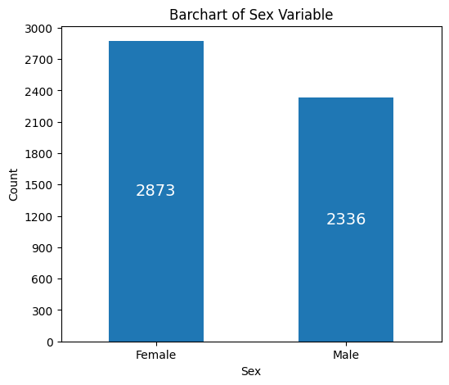

# Remove nan values for the 'AgeCHDdiag' numeric variable.
AgeCHDdiag_list = HEART_df['AgeCHDdiag'].values.tolist()
AgeCHDdiag_clean = [item for item in AgeCHDdiag_list if not(pd.isnull(item)) == True]
# Histogram for the 'AgeCHDdiag' numerical variable.
plt.hist(AgeCHDdiag_clean, bins = 30, alpha = 0.75, color = 'green', edgecolor = 'black')
plt.xlabel('AgeCHDdiag')
plt.ylabel('Frequency')
plt.xticks(np.arange(25,105,step=5))
plt.yticks(np.arange(0,141,step=10))
mean_value = statistics.mean(AgeCHDdiag_clean)
median_value = statistics.median(AgeCHDdiag_clean)
std_value = statistics.stdev(AgeCHDdiag_clean)
plt.axvline(mean_value, color='red', linewidth=2, label=f'Mean: {mean_value: .2f}')
plt.axvline(median_value, color='blue', linestyle='dashed', linewidth=1.5, label=f'Median: {median_value: .2f}')
plt.axvline(mean_value+std_value, color='red', linestyle='dashed', linewidth=1.5, label=f'1 SD')
plt.axvline(mean_value-std_value, color='red', linestyle='dashed', linewidth=1.5)
plt.axvline(mean_value+2*std_value, color='red', linestyle='dashed', linewidth=1, label=f'2 SD')
plt.axvline(mean_value-2*std_value, color='red', linestyle='dashed', linewidth=1)
plt.axvline(mean_value+3*std_value, color='red', linestyle='dashed', linewidth=0.5, label=f'3 SD')
plt.axvline(mean_value-3*std_value, color='red', linestyle='dashed', linewidth=0.5)
plt.show()
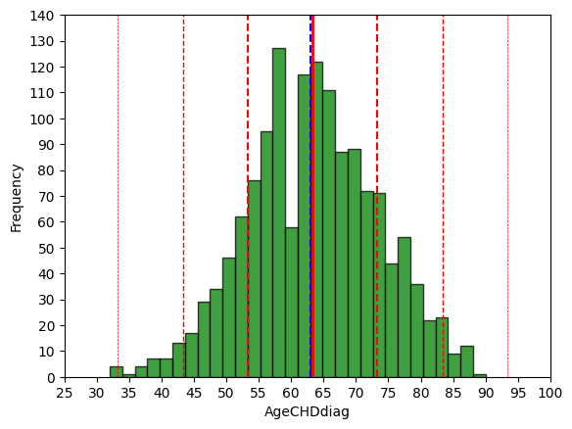

# Boxplot for the 'AgeCHDdiag' numeric variable.
fig = plt.figure(figsize =(5, 7))
ax = fig.add_subplot(111)
# Creating axes instance.
bp = ax.boxplot(AgeCHDdiag_clean, patch_artist = True,
notch ='True')
for patch, color in zip(bp['boxes'], 'green'):
patch.set_facecolor('green')
# Changing color and linewidth of whiskers.
for whisker in bp['whiskers']:
whisker.set(color ='green',
linewidth = 1.5,
linestyle =":")
# Changing color and linewidth of caps.
for cap in bp['caps']:
cap.set(color ='black',
linewidth = 2)
# Changing color and linewidth of median.
for median in bp['medians']:
median.set(color ='blue',
linewidth = 3)
# Changing style of fliers.
for flier in bp['fliers']:
flier.set(marker ='D',
alpha = 0.5)
# Set axis labels.
ax.set_ylabel('AgeCHDdiag')
ax.set_xticklabels('')
# Set axis limits.
plt.yticks(np.arange(25,101,step=5))
# Display the mean.
plt.axhline(mean_value, color='red', linewidth=1, linestyle='dashed', label=f'Mean: {mean_value: .2f}')
plt.show()
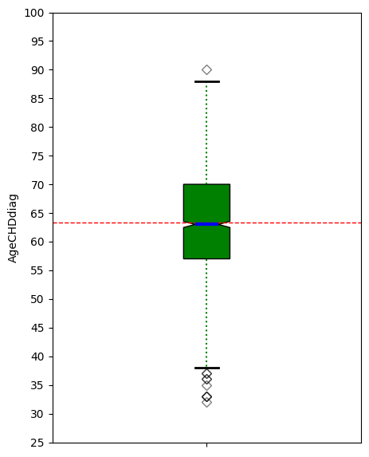
# 'AgeCHDdiag' Anderson-Darling Normality Test
result = anderson(AgeCHDdiag_clean)
print('Statistic: %.3f' % result.statistic)
p = 0
for i in range(len(result.critical_values)):
sl, cv = result.significance_level[i], result.critical_values[i]
if result.statistic < result.critical_values[i]:
print('%.3f: %.3f, data looks normal (fail to reject H0)' % (sl, cv))
else:
print('%.3f: %.3f, data does not look normal (reject H0)' % (sl, cv))
Statistic: 1.417
15.000: 0.574, data does not look normal (reject H0)
10.000: 0.654, data does not look normal (reject H0)
5.000: 0.785, data does not look normal (reject H0)
2.500: 0.915, data does not look normal (reject H0)
1.000: 1.089, data does not look normal (reject H0)
# 'AgeCHDdiag' QQ plot
qqplot(pd.array(AgeCHDdiag_clean), line='s')
plt.show()
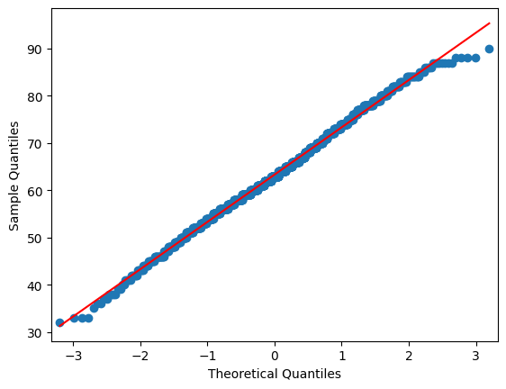

# Histogram for the 'AgeAtStart' numerical variable.
plt.hist(HEART_df['AgeAtStart'], bins = 30, alpha = 0.75, color = 'green', edgecolor = 'black')
plt.xlabel('AgeAtStart')
plt.ylabel('Frequency')
plt.xticks(np.arange(10,81,step=5))
plt.yticks(np.arange(0,501,step=50))
mean_value = HEART_df['AgeAtStart'].mean()
median_value = HEART_df['AgeAtStart'].median()
std_value = HEART_df['AgeAtStart'].std()
plt.axvline(mean_value, color='red', linewidth=2, label=f'Mean: {mean_value: .2f}')
plt.axvline(median_value, color='blue', linestyle='dashed', linewidth=1.5, label=f'Median: {median_value: .2f}')
plt.axvline(mean_value+std_value, color='red', linestyle='dashed', linewidth=1.5, label=f'1 SD')
plt.axvline(mean_value-std_value, color='red', linestyle='dashed', linewidth=1.5)
plt.axvline(mean_value+2*std_value, color='red', linestyle='dashed', linewidth=1, label=f'2 SD')
plt.axvline(mean_value-2*std_value, color='red', linestyle='dashed', linewidth=1)
plt.axvline(mean_value+3*std_value, color='red', linestyle='dashed', linewidth=0.5, label=f'3 SD')
plt.axvline(mean_value-3*std_value, color='red', linestyle='dashed', linewidth=0.5)
plt.show()
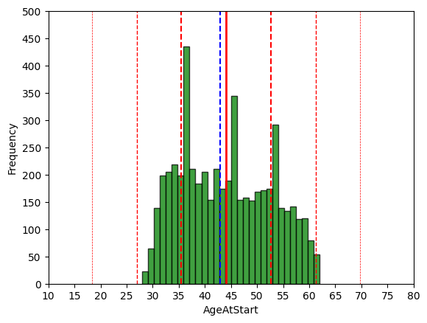

# Boxplot for the 'AgeAtStart' numeric variable.
fig = plt.figure(figsize =(5, 7))
ax = fig.add_subplot(111)
# Creating axes instance.
bp = ax.boxplot(HEART_df['AgeAtStart'], patch_artist = True,
notch ='True')
for patch, color in zip(bp['boxes'], 'green'):
patch.set_facecolor('green')
# Changing color and linewidth of whiskers.
for whisker in bp['whiskers']:
whisker.set(color ='green',
linewidth = 1.5,
linestyle =":")
# Changing color and linewidth of caps.
for cap in bp['caps']:
cap.set(color ='black',
linewidth = 2)
# Changing color and linewidth of median.
for median in bp['medians']:
median.set(color ='blue',
linewidth = 3)
# Changing style of fliers.
for flier in bp['fliers']:
flier.set(marker ='D',
alpha = 0.5)
# Set axis labels.
ax.set_ylabel('AgeAtStart')
ax.set_xticklabels('')
# Set axis limits.
plt.yticks(np.arange(20,71,step=5))
# Display the mean.
plt.axhline(mean_value, color='red', linewidth=1, linestyle='dashed', label=f'Mean: {mean_value: .2f}')
plt.show()
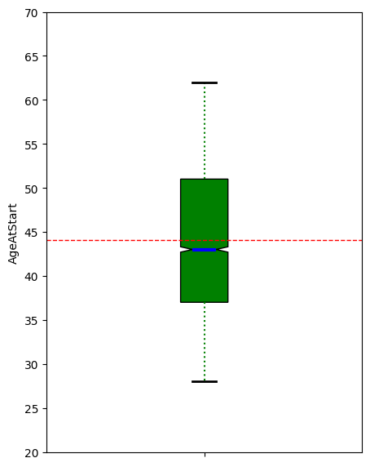
# 'AgeAtStart' Anderson-Darling Normality Test
result = anderson(HEART_df['AgeAtStart'])
print('Statistic: %.3f' % result.statistic)
p = 0
for i in range(len(result.critical_values)):
sl, cv = result.significance_level[i], result.critical_values[i]
if result.statistic < result.critical_values[i]:
print('%.3f: %.3f, data looks normal (fail to reject H0)' % (sl, cv))
else:
print('%.3f: %.3f, data does not look normal (reject H0)' % (sl, cv))
Statistic: 59.113
15.000: 0.576, data does not look normal (reject H0)
10.000: 0.655, data does not look normal (reject H0)
5.000: 0.786, data does not look normal (reject H0)
2.500: 0.917, data does not look normal (reject H0)
1.000: 1.091, data does not look normal (reject H0)
# 'AgeAtStart' QQ plot
qqplot(HEART_df['AgeAtStart'], line='s')
plt.show()
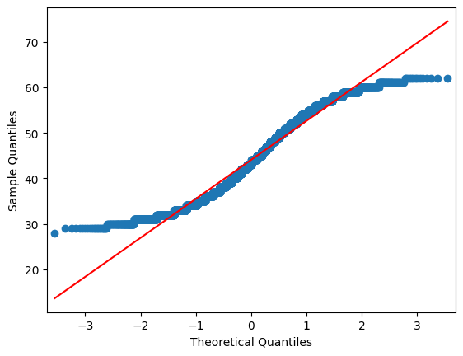

# Remove nan values for the 'Height' numeric variable.
Height_list = HEART_df['Height'].values.tolist()
Height_clean = [item for item in Height_list if not(pd.isnull(item)) == True]
# Histogram for the 'Height' numerical variable.
plt.hist(Height_clean, bins = 30, alpha = 0.75, color = 'green', edgecolor = 'black')
plt.xlabel('Height')
plt.ylabel('Frequency')
plt.xticks(np.arange(50,81,step=5))
plt.yticks(np.arange(0,551,step=50))
mean_value = statistics.mean(Height_clean)
median_value = statistics.median(Height_clean)
std_value = statistics.stdev(Height_clean)
plt.axvline(mean_value, color='red', linewidth=2, label=f'Mean: {mean_value: .2f}')
plt.axvline(median_value, color='blue', linestyle='dashed', linewidth=1.5, label=f'Median: {median_value: .2f}')
plt.axvline(mean_value+std_value, color='red', linestyle='dashed', linewidth=1.5, label=f'1 SD')
plt.axvline(mean_value-std_value, color='red', linestyle='dashed', linewidth=1.5)
plt.axvline(mean_value+2*std_value, color='red', linestyle='dashed', linewidth=1, label=f'2 SD')
plt.axvline(mean_value-2*std_value, color='red', linestyle='dashed', linewidth=1)
plt.axvline(mean_value+3*std_value, color='red', linestyle='dashed', linewidth=0.5, label=f'3 SD')
plt.axvline(mean_value-3*std_value, color='red', linestyle='dashed', linewidth=0.5)
plt.show()
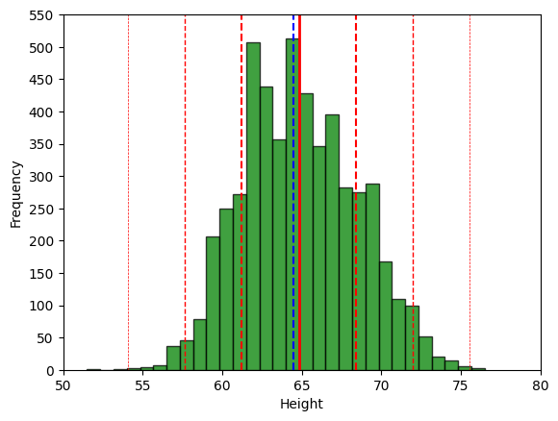

# Boxplot for the 'Height' numeric variable.
fig = plt.figure(figsize =(5, 7))
ax = fig.add_subplot(111)
# Creating axes instance.
bp = ax.boxplot(Height_clean, patch_artist = True,
notch ='True')
for patch, color in zip(bp['boxes'], 'green'):
patch.set_facecolor('green')
# Changing color and linewidth of whiskers.
for whisker in bp['whiskers']:
whisker.set(color ='green',
linewidth = 1.5,
linestyle =":")
# Changing color and linewidth of caps.
for cap in bp['caps']:
cap.set(color ='black',
linewidth = 2)
# Changing color and linewidth of median.
for median in bp['medians']:
median.set(color ='blue',
linewidth = 3)
# Changing style of fliers.
for flier in bp['fliers']:
flier.set(marker ='D',
alpha = 0.5)
# Set axis labels.
ax.set_ylabel('Height')
ax.set_xticklabels('')
# Set axis limits.
plt.yticks(np.arange(45,86,step=5))
# Display the mean.
plt.axhline(mean_value, color='red', linewidth=1, linestyle='dashed', label=f'Mean: {mean_value: .2f}')
plt.show()
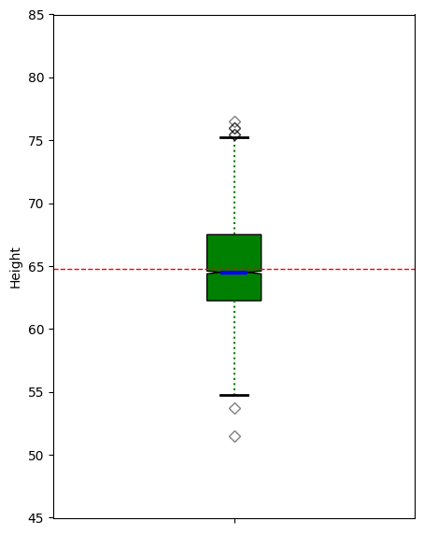
# 'Height' Anderson-Darling Normality Test
result = anderson(Height_clean)
print('Statistic: %.3f' % result.statistic)
p = 0
for i in range(len(result.critical_values)):
sl, cv = result.significance_level[i], result.critical_values[i]
if result.statistic < result.critical_values[i]:
print('%.3f: %.3f, data looks normal (fail to reject H0)' % (sl, cv))
else:
print('%.3f: %.3f, data does not look normal (reject H0)' % (sl, cv))
Statistic: 11.176
15.000: 0.576, data does not look normal (reject H0)
10.000: 0.655, data does not look normal (reject H0)
5.000: 0.786, data does not look normal (reject H0)
2.500: 0.917, data does not look normal (reject H0)
1.000: 1.091, data does not look normal (reject H0)
# 'Height' QQ plot
qqplot(pd.array(Height_clean), line='s')
plt.show()
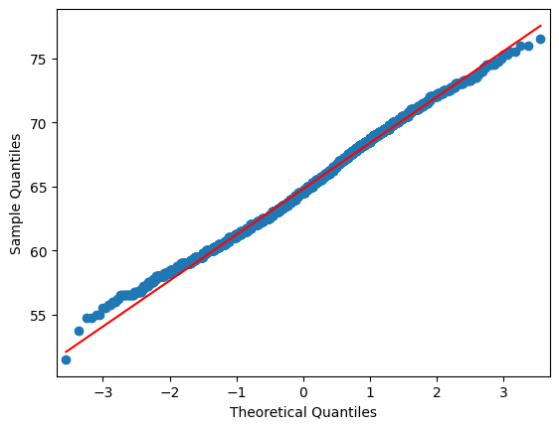

# Remove nan values for the 'Weight' numeric variable.
Weight_list = HEART_df['Weight'].values.tolist()
Weight_clean = [item for item in Weight_list if not(pd.isnull(item)) == True]
# Histogram for the 'Weight' numerical variable.
plt.hist(Weight_clean, bins = 30, alpha = 0.75, color = 'green', edgecolor = 'black')
plt.xlabel('Weight')
plt.ylabel('Frequency')
plt.xticks(np.arange(50,326,step=25))
plt.yticks(np.arange(0,651,step=50))
mean_value = statistics.mean(Weight_clean)
median_value = statistics.median(Weight_clean)
std_value = statistics.stdev(Weight_clean)
plt.axvline(mean_value, color='red', linewidth=2, label=f'Mean: {mean_value: .2f}')
plt.axvline(median_value, color='blue', linestyle='dashed', linewidth=1.5, label=f'Median: {median_value: .2f}')
plt.axvline(mean_value+std_value, color='red', linestyle='dashed', linewidth=1.5, label=f'1 SD')
plt.axvline(mean_value-std_value, color='red', linestyle='dashed', linewidth=1.5)
plt.axvline(mean_value+2*std_value, color='red', linestyle='dashed', linewidth=1, label=f'2 SD')
plt.axvline(mean_value-2*std_value, color='red', linestyle='dashed', linewidth=1)
plt.axvline(mean_value+3*std_value, color='red', linestyle='dashed', linewidth=0.5, label=f'3 SD')
plt.axvline(mean_value-3*std_value, color='red', linestyle='dashed', linewidth=0.5)
plt.show()
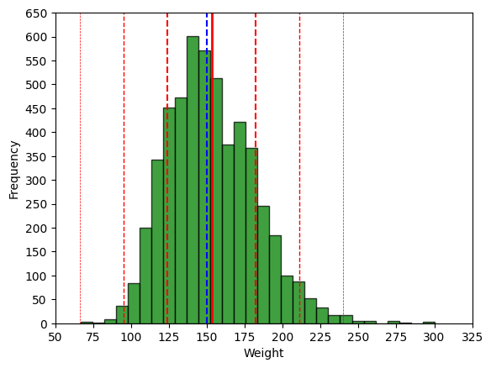

# Boxplot for the 'Weight' numeric variable.
fig = plt.figure(figsize =(5, 7))
ax = fig.add_subplot(111)
# Creating axes instance.
bp = ax.boxplot(Weight_clean, patch_artist = True,
notch ='True')
for patch, color in zip(bp['boxes'], 'green'):
patch.set_facecolor('green')
# Changing color and linewidth of whiskers.
for whisker in bp['whiskers']:
whisker.set(color ='green',
linewidth = 1.5,
linestyle =":")
# Changing color and linewidth of caps.
for cap in bp['caps']:
cap.set(color ='black',
linewidth = 2)
# Changing color and linewidth of median.
for median in bp['medians']:
median.set(color ='blue',
linewidth = 3)
# Changing style of fliers.
for flier in bp['fliers']:
flier.set(marker ='D',
alpha = 0.5)
# Set axis labels.
ax.set_ylabel('Weight')
ax.set_xticklabels('')
# Set axis limits.
plt.yticks(np.arange(50,326,step=25))
# Display the mean.
plt.axhline(mean_value, color='red', linewidth=1, linestyle='dashed', label=f'Mean: {mean_value: .2f}')
plt.show()
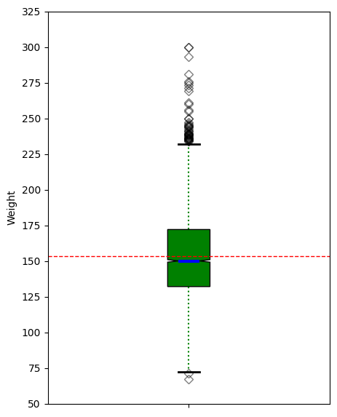
# 'Weight' Anderson-Darling Normality Test
result = anderson(Weight_clean)
print('Statistic: %.3f' % result.statistic)
p = 0
for i in range(len(result.critical_values)):
sl, cv = result.significance_level[i], result.critical_values[i]
if result.statistic < result.critical_values[i]:
print('%.3f: %.3f, data looks normal (fail to reject H0)' % (sl, cv))
else:
print('%.3f: %.3f, data does not look normal (reject H0)' % (sl, cv))
Statistic: 18.505
15.000: 0.576, data does not look normal (reject H0)
10.000: 0.655, data does not look normal (reject H0)
5.000: 0.786, data does not look normal (reject H0)
2.500: 0.917, data does not look normal (reject H0)
1.000: 1.091, data does not look normal (reject H0)
# 'Weight' QQ plot
qqplot(pd.array(Weight_clean), line='s')
plt.show()
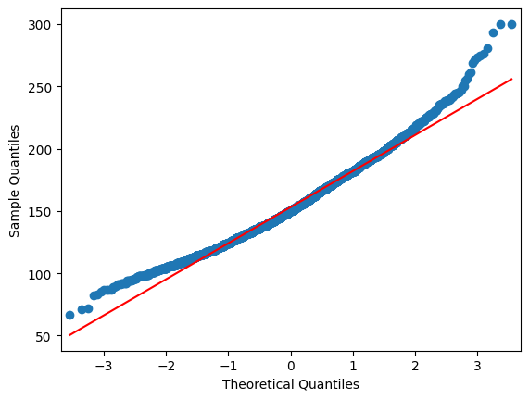

# Histogram for the 'Diastolic' numerical variable.
plt.hist(HEART_df['Diastolic'], bins = 30, alpha = 0.75, color = 'green', edgecolor = 'black')
plt.xlabel('Diastolic')
plt.ylabel('Frequency')
plt.xticks(np.arange(30,171,step=10))
plt.yticks(np.arange(0,1001,step=100))
mean_value = HEART_df['Diastolic'].mean()
median_value = HEART_df['Diastolic'].median()
std_value = HEART_df['Diastolic'].std()
plt.axvline(mean_value, color='red', linewidth=2, label=f'Mean: {mean_value: .2f}')
plt.axvline(median_value, color='blue', linestyle='dashed', linewidth=1.5, label=f'Median: {median_value: .2f}')
plt.axvline(mean_value+std_value, color='red', linestyle='dashed', linewidth=1.5, label=f'1 SD')
plt.axvline(mean_value-std_value, color='red', linestyle='dashed', linewidth=1.5)
plt.axvline(mean_value+2*std_value, color='red', linestyle='dashed', linewidth=1, label=f'2 SD')
plt.axvline(mean_value-2*std_value, color='red', linestyle='dashed', linewidth=1)
plt.axvline(mean_value+3*std_value, color='red', linestyle='dashed', linewidth=0.5, label=f'3 SD')
plt.axvline(mean_value-3*std_value, color='red', linestyle='dashed', linewidth=0.5)
plt.show()
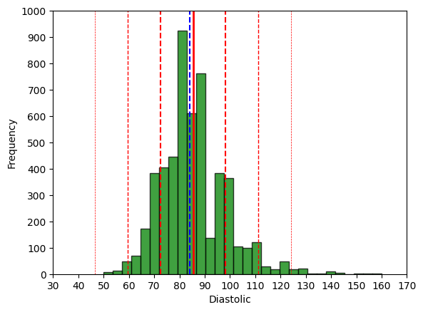

# Boxplot for the 'Diastolic' numeric variable.
fig = plt.figure(figsize =(5, 7))
ax = fig.add_subplot(111)
# Creating axes instance.
bp = ax.boxplot(HEART_df['Diastolic'], patch_artist = True,
notch ='True')
for patch, color in zip(bp['boxes'], 'green'):
patch.set_facecolor('green')
# Changing color and linewidth of whiskers.
for whisker in bp['whiskers']:
whisker.set(color ='green',
linewidth = 1.5,
linestyle =":")
# Changing color and linewidth of caps.
for cap in bp['caps']:
cap.set(color ='black',
linewidth = 2)
# Changing color and linewidth of median.
for median in bp['medians']:
median.set(color ='blue',
linewidth = 3)
# Changing style of fliers.
for flier in bp['fliers']:
flier.set(marker ='D',
alpha = 0.5)
# Set axis labels.
ax.set_ylabel('Diastolic')
ax.set_xticklabels('')
# Set axis limits.
plt.yticks(np.arange(40,171,step=10))
# Display the mean.
plt.axhline(mean_value, color='red', linewidth=1, linestyle='dashed', label=f'Mean: {mean_value: .2f}')
plt.show()
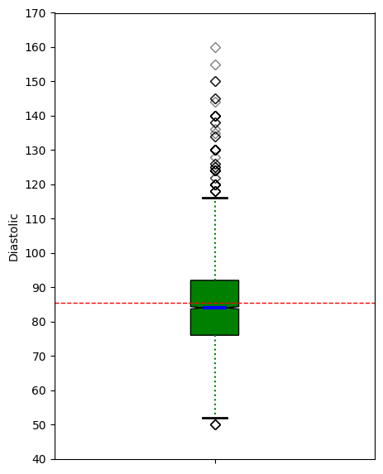
# 'Diastolic' Anderson-Darling Normality Test
result = anderson(HEART_df['Diastolic'])
print('Statistic: %.3f' % result.statistic)
p = 0
for i in range(len(result.critical_values)):
sl, cv = result.significance_level[i], result.critical_values[i]
if result.statistic < result.critical_values[i]:
print('%.3f: %.3f, data looks normal (fail to reject H0)' % (sl, cv))
else:
print('%.3f: %.3f, data does not look normal (reject H0)' % (sl, cv))
Statistic: 45.557
15.000: 0.576, data does not look normal (reject H0)
10.000: 0.655, data does not look normal (reject H0)
5.000: 0.786, data does not look normal (reject H0)
2.500: 0.917, data does not look normal (reject H0)
1.000: 1.091, data does not look normal (reject H0)
# 'Diastolic' QQ plot
qqplot(HEART_df['Diastolic'], line='s')
plt.show()
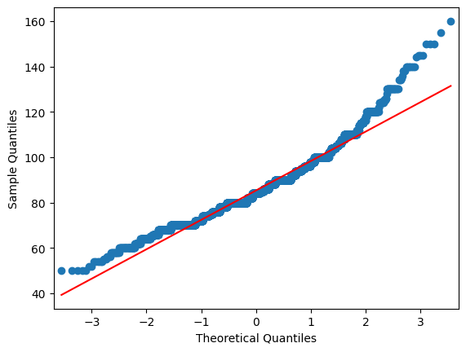

# Histogram for the 'Systolic' numerical variable.
plt.hist(HEART_df['Systolic'], bins = 30, alpha = 0.75, color = 'green', edgecolor = 'black')
plt.xlabel('Systolic')
plt.ylabel('Frequency')
plt.xticks(np.arange(50,326,step=25))
plt.yticks(np.arange(0,1001,step=100))
mean_value = HEART_df['Systolic'].mean()
median_value = HEART_df['Systolic'].median()
std_value = HEART_df['Systolic'].std()
plt.axvline(mean_value, color='red', linewidth=2, label=f'Mean: {mean_value: .2f}')
plt.axvline(median_value, color='blue', linestyle='dashed', linewidth=1.5, label=f'Median: {median_value: .2f}')
plt.axvline(mean_value+std_value, color='red', linestyle='dashed', linewidth=1.5, label=f'1 SD')
plt.axvline(mean_value-std_value, color='red', linestyle='dashed', linewidth=1.5)
plt.axvline(mean_value+2*std_value, color='red', linestyle='dashed', linewidth=1, label=f'2 SD')
plt.axvline(mean_value-2*std_value, color='red', linestyle='dashed', linewidth=1)
plt.axvline(mean_value+3*std_value, color='red', linestyle='dashed', linewidth=0.5, label=f'3 SD')
plt.axvline(mean_value-3*std_value, color='red', linestyle='dashed', linewidth=0.5)
plt.show()
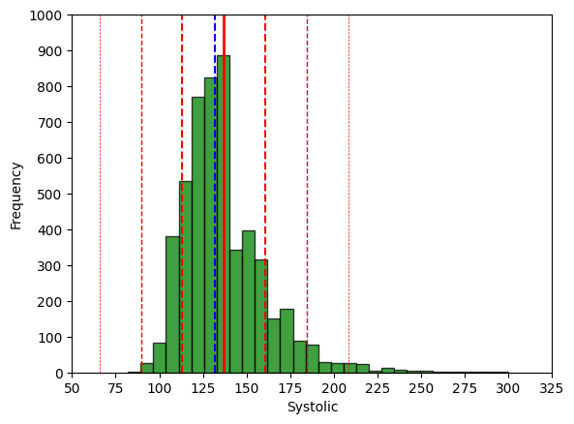

# Boxplot for the 'Systolic' numeric variable.
fig = plt.figure(figsize =(5, 7))
ax = fig.add_subplot(111)
# Creating axes instance.
bp = ax.boxplot(HEART_df['Systolic'], patch_artist = True,
notch ='True')
for patch, color in zip(bp['boxes'], 'green'):
patch.set_facecolor('green')
# Changing color and linewidth of whiskers.
for whisker in bp['whiskers']:
whisker.set(color ='green',
linewidth = 1.5,
linestyle =":")
# Changing color and linewidth of caps.
for cap in bp['caps']:
cap.set(color ='black',
linewidth = 2)
# Changing color and linewidth of median.
for median in bp['medians']:
median.set(color ='blue',
linewidth = 3)
# Changing style of fliers.
for flier in bp['fliers']:
flier.set(marker ='D',
alpha = 0.5)
# Set axis labels.
ax.set_ylabel('Systolic')
ax.set_xticklabels('')
# Set axis limits.
plt.yticks(np.arange(50,326,step=25))
# Display the mean.
plt.axhline(mean_value, color='red', linewidth=1, linestyle='dashed', label=f'Mean: {mean_value: .2f}')
plt.show()
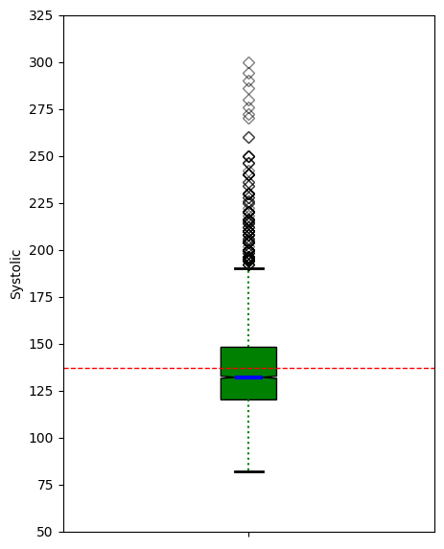
# 'Systolic' Anderson-Darling Normality Test
result = anderson(HEART_df['Systolic'])
print('Statistic: %.3f' % result.statistic)
p = 0
for i in range(len(result.critical_values)):
sl, cv = result.significance_level[i], result.critical_values[i]
if result.statistic < result.critical_values[i]:
print('%.3f: %.3f, data looks normal (fail to reject H0)' % (sl, cv))
else:
print('%.3f: %.3f, data does not look normal (reject H0)' % (sl, cv))
Statistic: 93.897
15.000: 0.576, data does not look normal (reject H0)
10.000: 0.655, data does not look normal (reject H0)
5.000: 0.786, data does not look normal (reject H0)
2.500: 0.917, data does not look normal (reject H0)
1.000: 1.091, data does not look normal (reject H0)
# 'Systolic' QQ plot
qqplot(HEART_df['Systolic'], line='s')
plt.show()
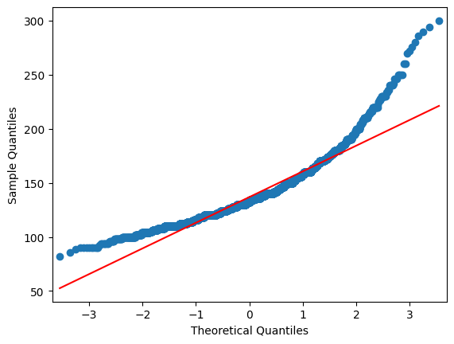

# Remove nan values for the 'MRW' numeric variable.
MRW_list = HEART_df['MRW'].values.tolist()
MRW_clean = [item for item in MRW_list if not(pd.isnull(item)) == True]
# Histogram for the 'MRW' numerical variable.
plt.hist(MRW_clean, bins = 30, alpha = 0.75, color = 'green', edgecolor = 'black')
plt.xlabel('MRW')
plt.ylabel('Frequency')
plt.xticks(np.arange(50,301,step=25))
plt.yticks(np.arange(0,901,step=50))
mean_value = statistics.mean(MRW_clean)
median_value = statistics.median(MRW_clean)
std_value = statistics.stdev(MRW_clean)
plt.axvline(mean_value, color='red', linewidth=2, label=f'Mean: {mean_value: .2f}')
plt.axvline(median_value, color='blue', linestyle='dashed', linewidth=1.5, label=f'Median: {median_value: .2f}')
plt.axvline(mean_value+std_value, color='red', linestyle='dashed', linewidth=1.5, label=f'1 SD')
plt.axvline(mean_value-std_value, color='red', linestyle='dashed', linewidth=1.5)
plt.axvline(mean_value+2*std_value, color='red', linestyle='dashed', linewidth=1, label=f'2 SD')
plt.axvline(mean_value-2*std_value, color='red', linestyle='dashed', linewidth=1)
plt.axvline(mean_value+3*std_value, color='red', linestyle='dashed', linewidth=0.5, label=f'3 SD')
plt.axvline(mean_value-3*std_value, color='red', linestyle='dashed', linewidth=0.5)
plt.show()
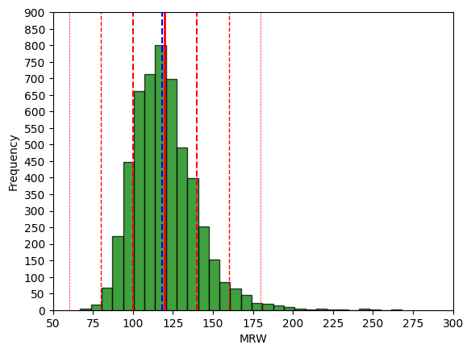

# Boxplot for the 'MRW' numeric variable.
fig = plt.figure(figsize =(5, 7))
ax = fig.add_subplot(111)
# Creating axes instance.
bp = ax.boxplot(MRW_clean, patch_artist = True,
notch ='True')
for patch, color in zip(bp['boxes'], 'green'):
patch.set_facecolor('green')
# Changing color and linewidth of whiskers.
for whisker in bp['whiskers']:
whisker.set(color ='green',
linewidth = 1.5,
linestyle =":")
# Changing color and linewidth of caps.
for cap in bp['caps']:
cap.set(color ='black',
linewidth = 2)
# Changing color and linewidth of median.
for median in bp['medians']:
median.set(color ='blue',
linewidth = 3)
# Changing style of fliers.
for flier in bp['fliers']:
flier.set(marker ='D',
alpha = 0.5)
# Set axis labels.
ax.set_ylabel('MRW')
ax.set_xticklabels('')
# Set axis limits.
plt.yticks(np.arange(50,301,step=25))
# Display the mean.
plt.axhline(mean_value, color='red', linewidth=1, linestyle='dashed', label=f'Mean: {mean_value: .2f}')
plt.show()
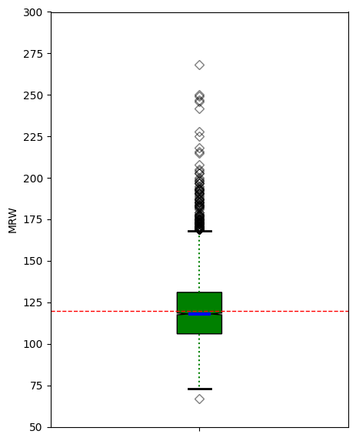
# 'MRW' Anderson-Darling Normality Test
result = anderson(MRW_clean)
print('Statistic: %.3f' % result.statistic)
p = 0
for i in range(len(result.critical_values)):
sl, cv = result.significance_level[i], result.critical_values[i]
if result.statistic < result.critical_values[i]:
print('%.3f: %.3f, data looks normal (fail to reject H0)' % (sl, cv))
else:
print('%.3f: %.3f, data does not look normal (reject H0)' % (sl, cv))
Statistic: 41.226
15.000: 0.576, data does not look normal (reject H0)
10.000: 0.655, data does not look normal (reject H0)
5.000: 0.786, data does not look normal (reject H0)
2.500: 0.917, data does not look normal (reject H0)
1.000: 1.091, data does not look normal (reject H0)
# 'MRW' QQ plot
qqplot(pd.array(MRW_clean), line='s')
plt.show()
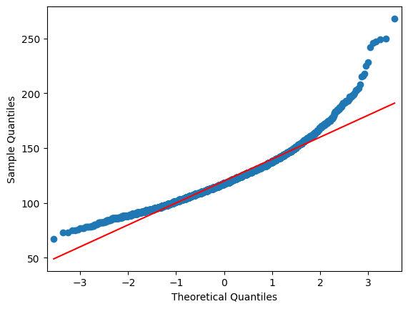

# Remove nan values for the 'Smoking' numeric variable.
Smoking_list = HEART_df['Smoking'].values.tolist()
Smoking_clean = [item for item in Smoking_list if not(pd.isnull(item)) == True]
# Barchart for the 'Smoking' numeric variable.
dfg = pd.array(Smoking_clean).value_counts()
ax = dfg.plot(kind='bar', title='Barchart of Smoking Variable', ylabel='Count', xlabel='Smoking', rot=0, figsize=(6,5))
ax.bar_label(ax.containers[0], label_type='edge', color='black', fontsize=8, fontweight='bold')
plt.yticks(np.arange(0,2701,step=100))
Smoking_unique = list(set(Smoking_clean))
Smoking_sort = sorted(Smoking_unique, reverse=False)
ax.set_xticklabels(Smoking_sort)
mean_value = statistics.mean(Smoking_clean)
plt.show()
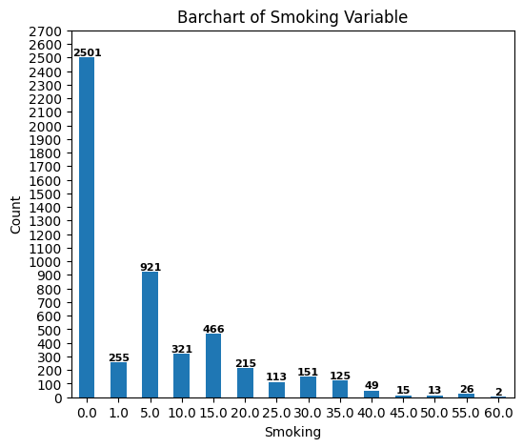
# Boxplot for the 'Smoking' numeric variable.
fig = plt.figure(figsize =(5, 7))
ax = fig.add_subplot(111)
# Creating axes instance.
bp = ax.boxplot(Smoking_clean, patch_artist = True,
notch ='True')
for patch, color in zip(bp['boxes'], 'green'):
patch.set_facecolor('green')
# Changing color and linewidth of whiskers.
for whisker in bp['whiskers']:
whisker.set(color ='green',
linewidth = 1.5,
linestyle =":")
# Changing color and linewidth of caps.
for cap in bp['caps']:
cap.set(color ='black',
linewidth = 2)
# Changing color and linewidth of median.
for median in bp['medians']:
median.set(color ='blue',
linewidth = 3)
# Changing style of fliers.
for flier in bp['fliers']:
flier.set(marker ='D',
alpha = 0.5)
# Set axis labels.
ax.set_ylabel('Smoking')
ax.set_xticklabels('')
# Set axis limits.
plt.yticks(np.arange(0,61,step=5))
# Display the mean.
plt.axhline(mean_value, color='red', linewidth=1, linestyle='dashed', label=f'Mean: {mean_value: .2f}')
plt.show()
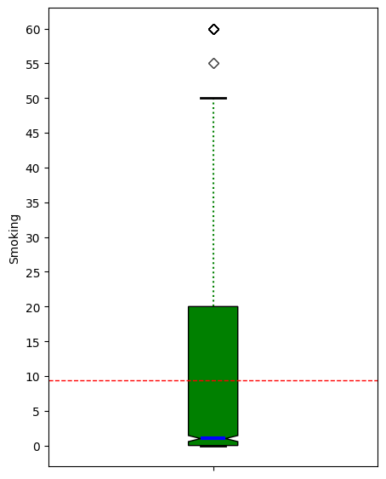

# Remove nan values for the 'AgeAtDeath' numeric variable.
AgeAtDeath_list = HEART_df['AgeAtDeath'].values.tolist()
AgeAtDeath_clean = [item for item in AgeAtDeath_list if not(pd.isnull(item)) == True]
# Histogram for the 'AgeAtDeath' numerical variable.
plt.hist(AgeAtDeath_clean, bins = 30, alpha = 0.75, color = 'green', edgecolor = 'black')
plt.xlabel('AgeAtDeath')
plt.ylabel('Frequency')
plt.xticks(np.arange(30,111,step=5))
plt.yticks(np.arange(0,181,step=20))
mean_value = statistics.mean(AgeAtDeath_clean)
median_value = statistics.median(AgeAtDeath_clean)
std_value = statistics.stdev(AgeAtDeath_clean)
plt.axvline(mean_value, color='red', linewidth=2, label=f'Mean: {mean_value: .2f}')
plt.axvline(median_value, color='blue', linestyle='dashed', linewidth=1.5, label=f'Median: {median_value: .2f}')
plt.axvline(mean_value+std_value, color='red', linestyle='dashed', linewidth=1.5, label=f'1 SD')
plt.axvline(mean_value-std_value, color='red', linestyle='dashed', linewidth=1.5)
plt.axvline(mean_value+2*std_value, color='red', linestyle='dashed', linewidth=1, label=f'2 SD')
plt.axvline(mean_value-2*std_value, color='red', linestyle='dashed', linewidth=1)
plt.axvline(mean_value+3*std_value, color='red', linestyle='dashed', linewidth=0.5, label=f'3 SD')
plt.axvline(mean_value-3*std_value, color='red', linestyle='dashed', linewidth=0.5)
plt.show()
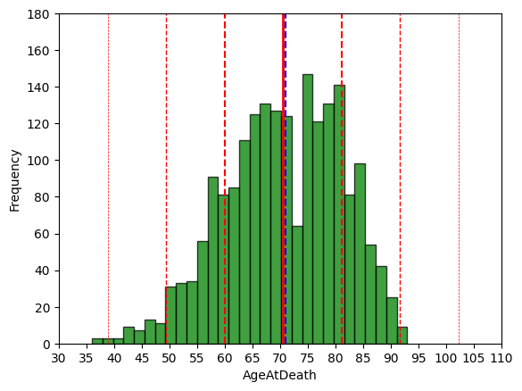

# Boxplot for the 'AgeAtDeath' numeric variable.
fig = plt.figure(figsize =(5, 7))
ax = fig.add_subplot(111)
# Creating axes instance.
bp = ax.boxplot(AgeAtDeath_clean, patch_artist = True,
notch ='True')
for patch, color in zip(bp['boxes'], 'green'):
patch.set_facecolor('green')
# Changing color and linewidth of whiskers.
for whisker in bp['whiskers']:
whisker.set(color ='green',
linewidth = 1.5,
linestyle =":")
# Changing color and linewidth of caps.
for cap in bp['caps']:
cap.set(color ='black',
linewidth = 2)
# Changing color and linewidth of median.
for median in bp['medians']:
median.set(color ='blue',
linewidth = 3)
# Changing style of fliers.
for flier in bp['fliers']:
flier.set(marker ='D',
alpha = 0.5)
# Set axis labels.
ax.set_ylabel('AgeAtDeath')
ax.set_xticklabels('')
# Set axis limits.
plt.yticks(np.arange(30,101,step=5))
# Display the mean.
plt.axhline(mean_value, color='red', linewidth=1, linestyle='dashed', label=f'Mean: {mean_value: .2f}')
plt.show()
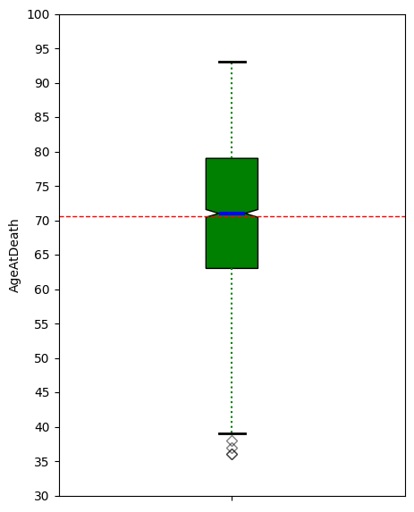
# 'AgeAtDeath' Anderson-Darling Normality Test
result = anderson(AgeAtDeath_clean)
print('Statistic: %.3f' % result.statistic)
p = 0
for i in range(len(result.critical_values)):
sl, cv = result.significance_level[i], result.critical_values[i]
if result.statistic < result.critical_values[i]:
print('%.3f: %.3f, data looks normal (fail to reject H0)' % (sl, cv))
else:
print('%.3f: %.3f, data does not look normal (reject H0)' % (sl, cv))
Statistic: 6.149
15.000: 0.575, data does not look normal (reject H0)
10.000: 0.655, data does not look normal (reject H0)
5.000: 0.785, data does not look normal (reject H0)
2.500: 0.916, data does not look normal (reject H0)
1.000: 1.090, data does not look normal (reject H0)
# 'AgeAtDeath' QQ plot
qqplot(pd.array(AgeAtDeath_clean), line='s')
plt.show()
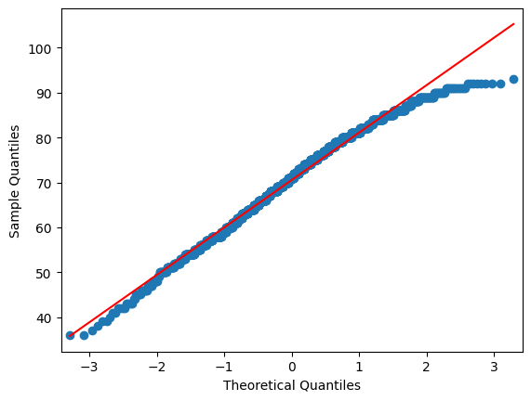

# Remove nan values for the 'Cholesterol' numeric variable.
Cholesterol_list = HEART_df['Cholesterol'].values.tolist()
Cholesterol_clean = [item for item in Cholesterol_list if not(pd.isnull(item)) == True]
# Histogram for the 'Cholesterol' numerical variable.
plt.hist(Cholesterol_clean, bins = 30, alpha = 0.75, color = 'green', edgecolor = 'black')
plt.xlabel('Cholesterol')
plt.ylabel('Frequency')
plt.xticks(np.arange(50,601,step=50))
plt.yticks(np.arange(0,801,step=50))
mean_value = statistics.mean(Cholesterol_clean)
median_value = statistics.median(Cholesterol_clean)
std_value = statistics.stdev(Cholesterol_clean)
plt.axvline(mean_value, color='red', linewidth=2, label=f'Mean: {mean_value: .2f}')
plt.axvline(median_value, color='blue', linestyle='dashed', linewidth=1.5, label=f'Median: {median_value: .2f}')
plt.axvline(mean_value+std_value, color='red', linestyle='dashed', linewidth=1.5, label=f'1 SD')
plt.axvline(mean_value-std_value, color='red', linestyle='dashed', linewidth=1.5)
plt.axvline(mean_value+2*std_value, color='red', linestyle='dashed', linewidth=1, label=f'2 SD')
plt.axvline(mean_value-2*std_value, color='red', linestyle='dashed', linewidth=1)
plt.axvline(mean_value+3*std_value, color='red', linestyle='dashed', linewidth=0.5, label=f'3 SD')
plt.axvline(mean_value-3*std_value, color='red', linestyle='dashed', linewidth=0.5)
plt.show()
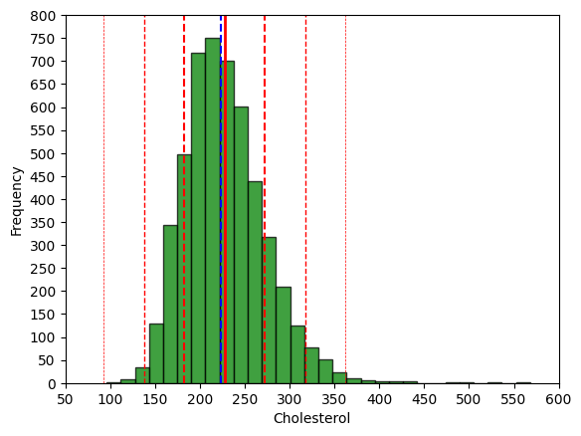

# Boxplot for the 'Cholesterol' numeric variable.
fig = plt.figure(figsize =(5, 7))
ax = fig.add_subplot(111)
# Creating axes instance.
bp = ax.boxplot(Cholesterol_clean, patch_artist = True,
notch ='True')
for patch, color in zip(bp['boxes'], 'green'):
patch.set_facecolor('green')
# Changing color and linewidth of whiskers.
for whisker in bp['whiskers']:
whisker.set(color ='green',
linewidth = 1.5,
linestyle =":")
# Changing color and linewidth of caps.
for cap in bp['caps']:
cap.set(color ='black',
linewidth = 2)
# Changing color and linewidth of median.
for median in bp['medians']:
median.set(color ='blue',
linewidth = 3)
# Changing style of fliers.
for flier in bp['fliers']:
flier.set(marker ='D',
alpha = 0.5)
# Set axis labels.
ax.set_ylabel('Cholesterol')
ax.set_xticklabels('')
# Set axis limits.
plt.yticks(np.arange(50,601,step=50))
# Display the mean.
plt.axhline(mean_value, color='red', linewidth=1, linestyle='dashed', label=f'Mean: {mean_value: .2f}')
plt.show()
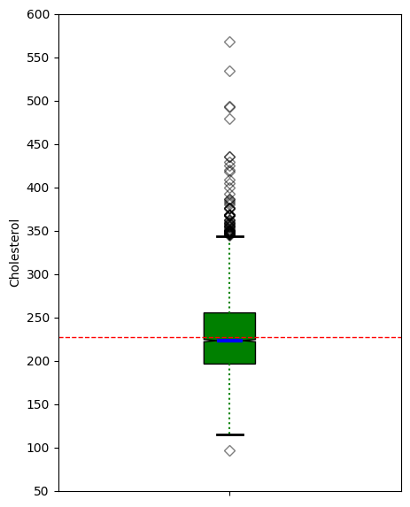
# 'Cholesterol' Anderson-Darling Normality Test
result = anderson(Cholesterol_clean)
print('Statistic: %.3f' % result.statistic)
p = 0
for i in range(len(result.critical_values)):
sl, cv = result.significance_level[i], result.critical_values[i]
if result.statistic < result.critical_values[i]:
print('%.3f: %.3f, data looks normal (fail to reject H0)' % (sl, cv))
else:
print('%.3f: %.3f, data does not look normal (reject H0)' % (sl, cv))
Statistic: 22.508
15.000: 0.576, data does not look normal (reject H0)
10.000: 0.655, data does not look normal (reject H0)
5.000: 0.786, data does not look normal (reject H0)
2.500: 0.917, data does not look normal (reject H0)
1.000: 1.091, data does not look normal (reject H0)
# 'Cholesterol' QQ plot
qqplot(pd.array(Cholesterol_clean), line='s')
plt.show()
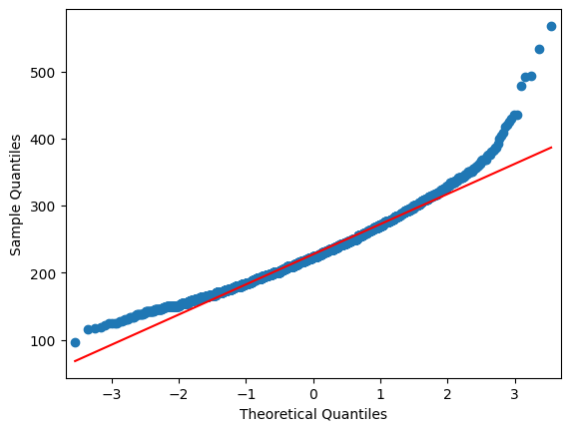

# Create dataframe for correlation analysis.
HEART_corr = HEART_df[['AgeCHDdiag','AgeAtStart','Height', 'Weight', 'Diastolic','Systolic', 'MRW', 'Smoking', 'AgeAtDeath','Cholesterol']]
# View summary statistics for males.
HEART_corr.describe().map('{:,.2f}'.format)
AgeCHDdiag AgeAtStart Height Weight Diastolic Systolic MRW
count 1,449.00 5,209.00 5,203.00 5,203.00 5,209.00 5,209.00 5,203.00
mean 63.30 44.07 64.81 153.09 85.36 136.91 119.96
std 10.02 8.57 3.58 28.92 12.97 23.74 19.98
min 32.00 28.00 51.50 67.00 50.00 82.00 67.00
25% 57.00 37.00 62.25 132.00 76.00 120.00 106.00
50% 63.00 43.00 64.50 150.00 84.00 132.00 118.00
75% 70.00 51.00 67.50 172.00 92.00 148.00 131.00
max 90.00 62.00 76.50 300.00 160.00 300.00 268.00
Smoking AgeAtDeath Cholesterol
count 5,173.00 1,991.00 5,057.00
mean 9.37 70.54 227.42
std 12.03 10.56 44.94
min 0.00 36.00 96.00
25% 0.00 63.00 196.00
50% 1.00 71.00 223.00
75% 20.00 79.00 255.00
max 60.00 93.00 568.00

# Generate heatmap for correlation matrix analysis.
corr = HEART_corr.corr()
fig, ax = plt.subplots()
sns.heatmap(corr, annot=True, fmt=".2f", xticklabels=corr.columns, yticklabels=corr.columns, vmin=-1, vmax=1, cmap="RdBu", ax=ax)
plt.show()
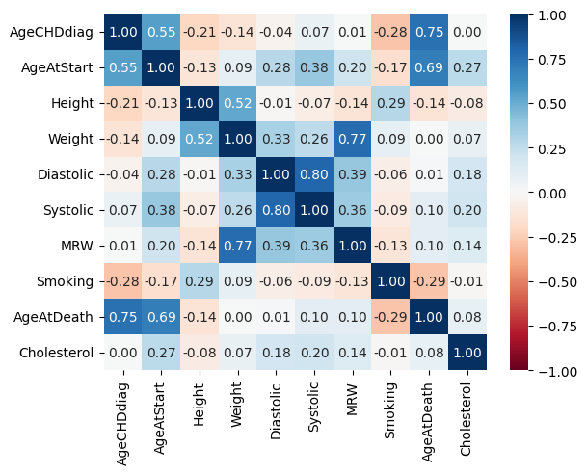

# Generate scatter plot matrix with correlation variables.
scatter_matrix(HEART_corr, diagonal="kde",figsize =(12, 12))
plt.show()
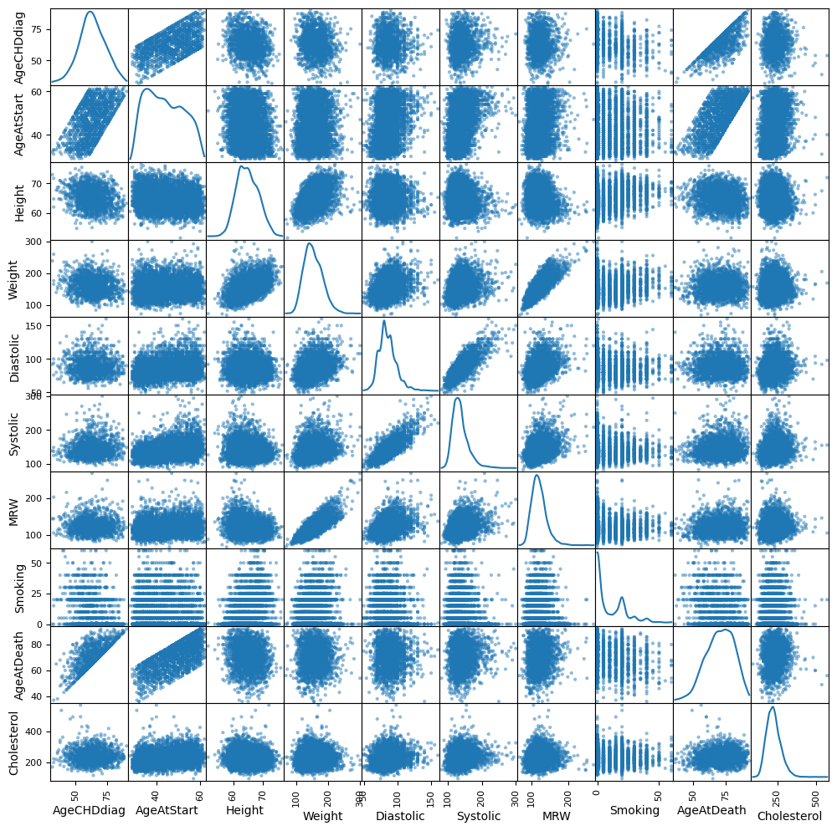

- Use t-tests to accept or reject the statements listed below. State conclusions using the terminology of hypothesis testing. (25 points)

There is no difference in cholesterol between males and females.

There is no difference in diastolic blood pressure between males and females.

# Create dataframe for t-test by removing reords with nan values in 'Cholesterol'.
HEART_trim = HEART_df
HEART_trim.dropna(subset = ['Cholesterol'], inplace=True)
(5057, 17)
# Regarding there is no difference in cholesterol between males and females.
# Barchart for the 'Sex' by mean 'Cholesterol'.
dfg = HEART_trim.groupby(['Sex'])['Cholesterol'].mean()
ax = dfg.plot(kind='bar', title='Mean Cholesterol by Sex', ylabel='Cholesterol', xlabel='Sex', rot=0, figsize=(6,5))
ax.bar_label(ax.containers[0], label_type='center', color='black', fontsize=16, fontweight='bold', fmt=lambda dfg: f'{dfg:.2f}')
plt.yticks(np.arange(0,251,step=25))
plt.show()
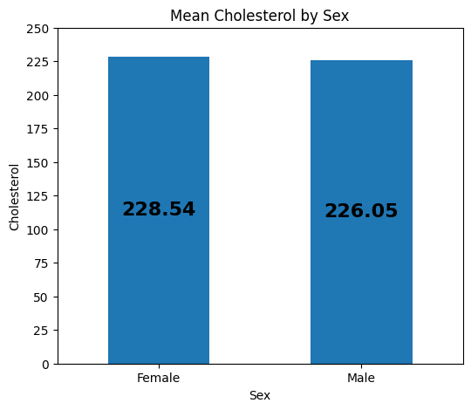

# Running a Two-Tailed Two-Sample T-Test in Python
# Define two independent samples.
class1_scores = HEART_trim.groupby("Sex").get_group("Female")['Cholesterol'].tolist()
class2_scores = HEART_trim.groupby("Sex").get_group("Male")['Cholesterol'].tolist()
# Perform two-sample t-test
t_statistic, p_value = ttest_ind(class1_scores, class2_scores)
# Output the results
print(f"t-statistic: {t_statistic:0,.3f}")
print(f"P-value: {p_value:0,.3f}")
t-statistic: 1.962
P-value: 0.050
Answer for 3.1: Because the above p-value is equal to the defined alpha 0f 0.05 (rejecting H0 the null hypothesis), and the t-statistic is positive, we can say the cholesterol for females (class 1) is higher with statistical significance than males (class 2).
# Barchart for the 'Sex' by mean 'Diastolic'.
dfg = HEART_df.groupby(['Sex'])['Diastolic'].mean()
ax = dfg.plot(kind='bar', title='Mean Diastolic by Sex', ylabel='Diastolic', xlabel='Sex', rot=0, figsize=(6,5))
ax.bar_label(ax.containers[0], label_type='center', color='black', fontsize=16, fontweight='bold', fmt=lambda dfg: f'{dfg:.2f}')
plt.yticks(np.arange(0,101,step=10))
plt.show()
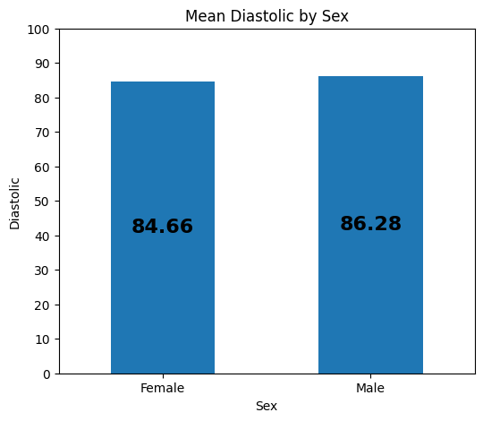
# Running a Two-Tailed Two-Sample T-Test in Python
# Define two independent samples.
class1_scores = HEART_df.groupby("Sex").get_group("Female")['Diastolic'].tolist()
class2_scores = HEART_df.groupby("Sex").get_group("Male")['Diastolic'].tolist()
# Perform two-sample t-test
t_statistic, p_value = ttest_ind(class1_scores, class2_scores)
# Output the results
print(f"t-statistic: {t_statistic:0,.3f}")
print(f"P-value: {p_value:0,.3f}")
t-statistic: -4.412
P-value: 0.000
Answer for 3.2: Because the above p-value is less than to the defined alpha 0f 0.05 (rejecting H0 the null hypothesis), and the t-statistic is negative, we can say the diastolic for males (class 2) is higher with statistical significance than females (class 1).

- Create 2 simple linear regression models that predict cholesterol: (20 points)

For the first model, use a continuous variable that exhibits the best correlation with the dependent variable.

For the second model, use a continuous variable that exhibits the next best correlation with the dependent variable.

# Calculate the Total Sum of Squares (SST) for an empty model for Cholesterol.
Y = HEART_trim['Cholesterol'].tolist()
Y_mean = np.mean(Y)
sst = np.sum((Y - Y_mean) ** 2)
print(f"SST = {sst:0,.3f}")
SST = 10,209,081.782

# 4.1 For the first simple model, use a continuous variable that exhibits the best correlation with the dependent variable.
# Create requested simple model and scatterplot. Used 'Cholesterol' the outcome variable and 'AgeAtStart' as the explanatory variable.
HEART_trim.plot("AgeAtStart", "Cholesterol", kind="scatter")
lm = smf.ols("Cholesterol ~ AgeAtStart", data=HEART_trim).fit()
xmin = HEART_trim.AgeAtStart.min()
xmax = HEART_trim.AgeAtStart.max()
X = np.linspace(xmin, xmax, 100)
# params[0] is the intercept (beta₀) & params[1] is the slope (beta₁)
Y = lm.params[0] + lm.params[1] * X
plt.plot(X, Y, color="darkred")
plt.show()
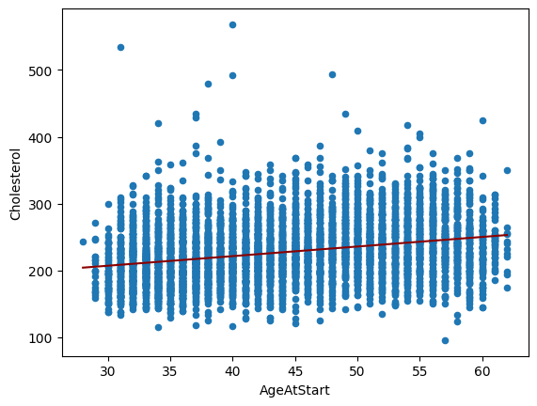

# Generate OLS Regression results for the simple model.
print(lm.summary())
print('\n')
# Residual Sum of Squares
print(f"RSS = {lm.ssr:0,.3f}")
# Sum of Squares Error
print(f"SSE = {sst-lm.ssr:0,.3f}")
OLS Regression Results
=============================================================================
Dep. Variable: Cholesterol R-squared: 0.075
Model: OLS Adj. R-squared: 0.075
Method: Least Squares F-statistic: 408.4
Date: Sun, 16 Feb 2025 Prob (F-statistic): 2.12e-87
Time: 16:27:29 Log-Likelihood: -26222.
No. Observations: 5057 AIC: 5.245e+04
Df Residuals: 5055 BIC: 5.246e+04
Df Model: 1
Covariance Type: nonrobust
=============================================================================
coef std err t P>|t| [0.025 0.975]
-----------------------------------------------------------------------------
Intercept 164.2427 3.185 51.575 0.000 158.000 170.486
AgeAtStart 1.4334 0.071 20.209 0.000 1.294 1.572
=============================================================================
Omnibus: 808.399 Durbin-Watson: 2.011
Prob(Omnibus): 0.000 Jarque-Bera (JB): 2232.457
Skew: 0.859 Prob(JB): 0.00
Kurtosis: 5.765 Cond. No. 235.
=============================================================================
RSS = 9,445,895.982
SSE = 763,185.800
4.1 Explain the tabular and graphical output that is produced.
Of all of the numeric variables, AgeAtStart had the highest absolute correlation (0.27) with Cholesterol, so it made sense to choose it for the explanatory variable in the simple model. In addition, neither variable passed normality tests, with AgeAtStart having potential multi-modality and kurtosis in its distribution. Although, the fitted regression line in the graphical output seems to reasonably traverse through the data.
The R-squared value of 0.075 indicates that 7.5% of the variation in the predicted Cholesterol values can be explained by AgeAtStart in this simple model. The Y intercept, beta0, equals 164.2427 at 0 years of AgeAtStart, and the regression line slope, beta1, equals 1.4334 per 1 year of AgeAtStart. The F-statistic of 408.4 easily exceeds any reasonable threshold. The p-value is nearly zero and safely under the 0.05 alpha standard (rejecting H0 the null hypothesis), indicating clearly that the relationship between Cholesterol and AgeAtStart is statistically significant.
# 4.1 For the first simple model, use a continuous variable that exhibits the second best correlation with the dependent variable.
# Create requested simple model and scatterplot. Used 'Cholesterol' the outcome variable and 'Systolic' as the explanatory variable.
HEART_trim.plot("Systolic", "Cholesterol", kind="scatter")
lm = smf.ols("Cholesterol ~ Systolic", data=HEART_trim).fit()
xmin = HEART_trim.Systolic.min()
xmax = HEART_trim.Systolic.max()
X = np.linspace(xmin, xmax, 100)
# params[0] is the intercept (beta₀) & params[1] is the slope (beta₁)
Y = lm.params[0] + lm.params[1] * X
plt.plot(X, Y, color="darkred")
plt.show()
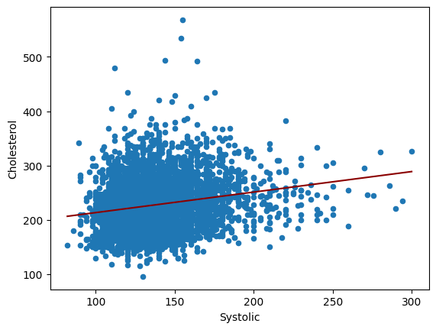

# Generate OLS Regression results for the simple model.
print(lm.summary())
print('\n')
# Residual Sum of Squares
print(f"RSS = {lm.ssr:0,.3f}")
# Sum of Squares Error
print(f"SSE = {sst-lm.ssr:0,.3f}")
OLS Regression Results
=============================================================================
Dep. Variable: Cholesterol R-squared: 0.040
Model: OLS Adj. R-squared: 0.040
Method: Least Squares F-statistic: 209.2
Date: Sun, 16 Feb 2025 Prob (F-statistic): 1.72e-46
Time: 17:13:39 Log-Likelihood: -26316.
No. Observations: 5057 AIC: 5.264e+04
Df Residuals: 5055 BIC: 5.265e+04
Df Model: 1
Covariance Type: nonrobust
=============================================================================
coef std err t P>|t| [0.025 0.975]
-----------------------------------------------------------------------------
Intercept 175.7667 3.624 48.496 0.000 168.661 182.872
Systolic 0.3771 0.026 14.464 0.000 0.326 0.428
=============================================================================
Omnibus: 701.193 Durbin-Watson: 1.999
Prob(Omnibus): 0.000 Jarque-Bera (JB): 1562.088
Skew: 0.820 Prob(JB): 0.00
Kurtosis: 5.173 Cond. No. 814.
=============================================================================
RSS = 9,803,367.325
SSE = 405,714.456
4.2 Explain the tabular and graphical output that is produced.
As required, Systolic had the second highest absolute correlation (0.20) with Cholesterol, so it made sense to choose it for the explanatory variable in the simple model. In addition, neither variable passed normality tests, but Cholesterol and Systolic shared a similarly right skewed distribution. The fitted regression line in the graphical output seems to reasonably traverse through the data.
The R-squared value of 0.040 indicates that 4% of the variation in the predicted Cholesterol values can be explained by Systolic in this simple model. The Y intercept, beta0, equals 175.7667 at 0 value of Systolic, and the regression line slope, beta1, equals 0.3771 per 1 value of Systolic. The F-statistic of 209.2 easily exceeds any reasonable threshold. The p-value is nearly zero and safely under the 0.05 alpha standard (rejecting H0 the null hypothesis), indicating clearly that the relationship between Cholesterol and Systolic is statistically significant.
4 Explain and support the difference between the models from the previous two steps.
The low R squared values, extremely low Log-Likelihood values, and very high AIC/BIC values indicate that neither of these simple models would be a good predictor of cholesterol. Although, both AgeAtStart and Systolic demonstrated statistical significance with their p-values, t-values, and F statistics to Cholesterol, and could belong to MLR model that could explain more variation. By way of comparison, AgeAtStart simple model explained about 88.1% more variation the Systolic simple model.
When looking at the AgeAtStart distribution, there is probably a transformation that could be used to achieve normality, but I was not able to put my finger on it. Cholesterol had 152 missing values, so I chose to drop the records associated with them. If AgeAtStart and/or Systolic had a significant correlation with Cholesterol, I would have tried impute the missing values based on one or both of them. Will use the reduced dataframe with the MLR model in Question 5, given that none of the continuous variables have a significant correlation with Cholesterol.
- Create a multiple regression model that uses all of the continuous variables. (30 points)
Explain and support the results of the model.

Compare the performance of the multiple regression model with the best bilinear regression model from question 4 (the bilinear model).

# Generate number of missing values.
HEART_trim.isna().sum()
Status 0
DeathCause 3135
AgeCHDdiag 3649
Sex 0
AgeAtStart 0
Height 6
Weight 6
Diastolic 0
Systolic 0
MRW 6
Smoking 8
AgeAtDeath 3135
Cholesterol 0
Chol_Status 0
BP_Status 0
Weight_Status 6
Smoking_Status 8
dtype: int64
Note: Will remove AgeCHDdiag and AgeAtDeath from the MLR model, due to the extremely large number of missing values associated with each. Will impute the missing values for Height, Weight, MRW, and Smoking with their respective median values.
# Performed necessary imputations.
HEART_trim.fillna(HEART_trim['Height'].median(), inplace=True)
HEART_trim.fillna(HEART_trim['Weight'].median(), inplace=True)
HEART_trim.fillna(HEART_trim['MRW'].median(), inplace=True)
HEART_trim.fillna(HEART_trim['Smoking'].median(), inplace=True)
# 5 A multiple regression model using Cholesterol and all of the designated continuous variables.
lm = smf.ols(formula='Cholesterol ~ AgeAtStart + Height + Weight + Diastolic + Systolic + MRW + Smoking', data=HEART_trim).fit()
print(lm.params)
Intercept 289.593442
AgeAtStart 1.206918
Height -2.506843
Weight 0.359344
Diastolic 0.249216
Systolic 0.073467
MRW -0.341667
Smoking 0.186225
dtype: float64
# Generate OLS Regression results for the initial multiple linear regression model.
print(lm.summary())
print('\n', '='*20, '\n')
# Residual Sum of Squares
print(f"RSS = {lm.ssr:0,.3f}")
# Sum of Squares Error
print(f"SSE = {sst-lm.ssr:0,.3f}")
OLS Regression Results
=============================================================================
Dep. Variable: Cholesterol R-squared: 0.095
Model: OLS Adj. R-squared: 0.094
Method: Least Squares F-statistic: 75.72
Date: Sun, 16 Feb 2025 Prob (F-statistic): 9.63e-105
Time: 18:36:23 Log-Likelihood: -26166.
No. Observations: 5057 AIC: 5.235e+04
Df Residuals: 5049 BIC: 5.240e+04
Df Model: 7
Covariance Type: nonrobust
=============================================================================

coef std err t P>|t| [0.025 0.975]
-----------------------------------------------------------------------------
Intercept 289.5934 53.077 5.456 0.000 185.539 393.648
AgeAtStart 1.2069 0.077 15.616 0.000 1.055 1.358
Height -2.5068 0.820 -3.058 0.002 -4.114 0.899
Weight 0.3593 0.158 2.279 0.023 0.050 0.668
Diastolic 0.2492 0.079 3.159 0.002 0.095 0.404
Systolic 0.0735 0.044 1.669 0.095 -0.013 0.160
MRW -0.3417 0.198 -1.727 0.084 -0.729 0.046
Smoking 0.1862 0.052 3.562 0.000 0.084 0.289
=============================================================================
Omnibus: 796.039 Durbin-Watson: 2.004
Prob(Omnibus): 0.000 Jarque-Bera (JB): 2195.463
Skew: 0.847 Prob(JB): 0.00
Kurtosis: 5.748 Cond. No. 2.35e+04
=============================================================================
RSS = 9,239,143.375
SSE = 969,938.406
# Generate the absolute critical t-statistic.
t_critical = abs(scipy.stats.t.ppf(q=.05/2,df=7))
print(f'{t_critical:.3f}')
2.365
4.2 Explain and support the results of the model.
The R-squared value of 0.095 indicates that 9.5% of the variation in the predicted Cholesterol values can be attributed to this multiple linear regression model. The Y intercept, beta0, equals a 289.5934 base value. AgeAtStart, beta1, equals 1.2069 per 1 year of AgeAtStart, Height, beta2, equals -2.5068 per 1 inch of Height, Weight, beta3, equals 0.03593 per 1 lbs of Weight, Diastolic, beta4, equals 0.2492 per 1 unit of Diastolic, Systolic, beta5, equals 0.0735 per 1 unit of Systolic, MRW, beta6, equals -0.3417 per 1 unit of MRW, and Smoking, beta7, equals 0.1862 per 1 cigarette smoked per day. The F-statistic of 75.72 exceeds any reasonable threshold. Regarding AgeAtStart, Height, Weight, Diastolic, and Smoking, the p-value is less than the 0.05 alpha standard (rejecting H0 the null hypothesis), indicating clearly that the relationship between Cholesterol and those explanatory variables are statistically significant. Regarding Systolic and MRW, the p-value is greater than the 0.05 alpha standard (accepting H0 the null hypothesis), indicating that the relationship between Cholesterol and those explanatory variables are not statistically significant.
MRW has a 0.77 correlation with Weight, and Systolic has a 0.80 correlation with Diastolic. Can easily see removing these two variables from the MLR model. As I previously stated, the AgeAtStart variable could use some type of transformation to achieve better normality, and possibly Diastolic as well.
Compare the performance of the multiple regression model with the best bilinear regression model from question 4 (the bilinear model).
With Cholesterol having a SST of 10,209,081.782, the simple model using the AgeAtStart variable reduced it 763,185.8 to a SSR of 9,445,895.982, which amounts to an approximate 7.5% reduction, the simple model using the Systolic variable reduced it 405,714.456 to a SSR of 9,803,367.326, which amounts to an approximate 4% reduction. The multiple linear regression model using AgeAtStart, Height, Weight, Diastolic, Systolic, MRW, and Smoking variables reduced it 969,938.406 to a SSR of 9,239,143.375, which amounts to an approximate 9.5% reduction. Adding six more variables, or degrees of freedom, yielded only a 2% gain in reduction. Could improve some, if the two heavily correlated variables are removed, and some variable transformations are sought. A couple of the categorical variables could possibly be used, but I had trouble imagining where they would be any more informative than their numerical counterparts. As with the simple models, the low R squared value, extremely low Log-Likelihood value, and very high AIC/BIC values are an indicator that this MLR model, and possibly any MLR model from this dataset would not be a good predictor of cholesterol.

